

USPS SOA-Mobile Workstream

[You can add an abstract or other key statement here. An abstract is typically a short summary of the document content.]

| **Prepared by:** | Steven Dickson, Yue Chao Qin, Jody Sevidal |
| --- | --- |
| **Owner:** | Agilex Government Services Sector |
| **Project ID:** | SOA Governance and Development, Task #6 |
| **Project Sponsor(s):** | Farah Bandukwala, USPS Solution Architect |
| **Portfolio:** | USPS Information Technology |
| **Date Created:** | 07.07.2014 |
| **Date Last Modified:** | 09.30.2014 |

Table of Contents

I. USPS SOA Mobile Workstream 6

A. Background 6

B. Purpose of SOA relative to other work streams 6

C. General Approach 8

II. Repeatable Framework 9

A. Objective 9

B. Use Case 10

C. General Implementation Procedures 11

D. SOA Configuration and Points of Contact 11

III. Pagination Web Service Prototype 12

A. Scope 12

B. Methodology, Tools, and Techniques 13

C. Design Overview 16

D. Design Objective 16

E. System Architecture 16

F. Software Environment (including Interfaces) 18

G. Design Constraints 19

H. Risks 19

I. Issues 19

J. Assumptions 19

K. Performance Requirements 20

L. Databases (Oracle, DB2, SQL Server, Other) 20

M. Components List 20

N. Component Flow 20

O. Supporting Documentation 21

P. Operational Controls 25

Q. Startup and Shutdown 25

R. Audit and Recovery 26

S. Restart 26

T. Backup Strategy 26

U. Fallback Strategy 26

V. Security/Compliance Design Strategies 26

1. Operating System–Level Security Strategy 26

2. Database-Level Security Strategy 26

3. Application-Level Security Strategy 27

IV. IBM DataPower 29

A. Overview 29

B. API Definition 29

C. Input 29

D. Request 30

E. Response 31

F. Configure DataPower 31

G. Test 34

H. Configure Consumer Application 35

1. Configuration 35

I. Example 35

J. Appendix 38

1. POST API Complete Definition 38

2. GET API Definition 38

V. IBM Websphere Service Registry and Repository 40

A. Purpose 40

B. Configuring a Service Catalog in WSRR 8.5 40

C. Exporting a Service Catalog in WSRR 8.5 47

VI. IBM DataPower and Websphere Registry and Repository 51

A. API Definition 51

1. Input 51

B. Request 52

C. Response 53

D. Configure WSRR 53

E. Configure DataPower 55

1. Create Service Proxy 55

2. Subscribe REST service from WSRR 55

F. Test 56

G. Configure Consumer Application 56

H. Appendix 59

1. POST API Complete Definition 59

2. GET API Definition 59

3. How to register a REST service in WSSR 60

4. Register WSSR server in DataPower 63

5. Creating an SSL Proxy Profile for WSSR in DataPower 63

6. Configure WSRR Server Connection in DataPower 64

7. Using DataPower with WSRR and REST services 65

VII. IBM Integration Bus 66

A. Creating a Manager Broker 68

B. Deploying a Flow in IIB 71

VIII. HTTP Access Control in the USPS SOA Environment 74

A. Introduction 74

B. Problem 75

1. Same-Origin Policy (SOP) 75

C. Common Solutions 76

1. CORS 76

2. “Simple” HTTP Request 78

3. “Not-so-simple” HTTP Request 78

4. Details of CORS request 79

5. Summary 80

6. Proxy Server 81

D. Implemented Solutions 81

1. Server CORS Filter 81

2. Pros 82

3. Cons 82

E. DataPower CORS solution 82

1. Pros 83

2. Cons 84

F. Proxy Server 84

1. Pros 85

2. Cons 85

G. Appendix A – Same-origin policy examples 85

IX. As-Is and To-Be Web Services 86

X. USPS SOA-Mobile Reference Architecture 89

A. Objective 89

B. USPS Services Oriented Architecture Technology 89

C. Context of SOA within the Mobile Computing Framework Architecture 90

D. Mobile SOA Reference Architecture 91

1. What is a Reference Architecture? 91

2. Use Cases 91

3. Objectives: 91

4. Description of Layers 92

E. USPS SOA Architecture Pattern 95

F. DataPower as ESB Dataflow – Scenario A 96

G. DataPower as ESB Dataflow – Scenario B 97

H. IBM Integration Bus (IIB) as ESB Dataflow – Scenario A 98

I. IBM Integration Bus (IIB) as ESB dataflow – Scenario B 99

J. Decision Points 100

1. DataPower 100

2. DataPower and WSRR 101

3. DataPower and IIB 101

4. REST, SOAP, JSON, and XML 102

5. Others 103

XI. Sprint Backlog 105

**TABLE OF FIGURES**

Figure 1: Before SOA 10

Figure 2: After SOA 10

Figure 3: Example Use Case for how Repeatable Framework can be used within a governance model 12

Figure 4 - Logical Architecture 19

Figure 5 - High Level System Logic Flow 20

Figure 6 - Software Environment 21

Figure 7 - Software Components 22

Figure 8 - Component Flow Sequence Diagram 23

Figure 9 - REST API Call List 24

Figure 10 - Pagination Data Example 26

Figure 11: DataPower front side configurations 35

Figure 12: DataPower back side configurations 36

Figure 13: Consumer application configuration for REST URL endpoint 37

Figure 14: "Before" architecture example for consumer application 38

Figure 15: "After" architecture example for consumer application 39

Figure 16- Log In screen 42

Figure 17- Service Catalog Menu 43

Figure 18- Service Catalog View 43

Figure 19- Edit Page menu option 44

Figure 20- Edit Settings menu option 44

Figure 21- All Listed Types menu option 45

Figure 22- Search Display Settings 45

Figure 23 - Finish editing page button 46

Figure 24- Edit Confirmation 46

Figure 25 - Search Catalog 46

Figure 26- Catalog View with REST Services 47

Figure 27- REST Endpoint Detail 48

Figure 28- WSSR Console Home page 49

Figure 29- Business Object Selection box 49

Figure 30- REST Service Endpoint view 50

Figure 31- Export file 51

Figure 32: Consumer application configuration for REST URL endpoint 58

Figure 33: "Before" architecture example for consumer application 59

Figure 34: "After" architecture example for consumer application 60

Figure 35- Use Case API Architecture 76

Figure 36- Access Control Issues 78

Figure 37: Common HTTP Header Fields sent in a HTTP Request or Response 79

Figure 38: CORS flow 81

Figure 39: Server CORS Filter Solution 84

Figure 40: DataPower CORS Filter Solution 85

Figure 41: Proxy Server Solution 86

# USPS SOA Mobile Workstream

## Background

In FY13, USPS IT organization developed the USPS Enterprise Mobile Vision, Strategy and Roadmap, which included enterprise mobility implementation, service oriented architecture, and governance support. The Service Oriented Architecture (SOA) Governance and Development task was one of the many pilot projects within USPS’ Enterprise Mobile Vision, Strategy and Roadmap to support both mobile and web applications from a SOA perspective. The objective of this pilot is to prove out and mature the investment made by USPS in SOA technology. The USPS SOA is based on IBM’s proprietary SOA tools that include IBM DataPower appliance, IBM Websphere Registry and Repository (WSRR), and the IBM Integration Bus (IIB). These will be explained further and show how they integrate with existing applications

## Purpose of SOA relative to other work streams

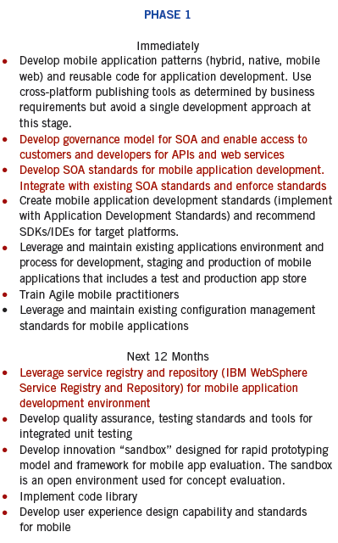SOA technologies is part of USPS broader strategy outlined in the USPS Mobile Computing Roadmap which includes over 80 recommendations that cover: Enhance Mobile Portal Application, Service Orientated Architecture, Mobile Device Management, Mobile Computing Governance, USPS Mobile Security Framework and Development of Mobile Apps within USPS Mobile Portal App.



A common goal for SOA relative to the Roadmap is to enable the development and use of shared web services deployed in the USPS SOA environment for mobile applications. This has been extended for non-mobile based systems and/or web based applications as well. The benefits and features of using SOA include (from TOGAF):

|  |  |  |
| --- | --- | --- |
| Feature | Benefits | IBM SOA Implementation |
| [Service](http://www.opengroup.org/soa/source-book/soa/soa_features.htm#soafabserv) | Improved information flow  Ability to expose internal functionality  Organizational flexibility | All IBM SOA tools |
| [Service Re-use](http://www.opengroup.org/soa/source-book/soa/soa_features.htm#soafabsvcreuse) | Lower software development and management costs | IBM WSSR |
| [Messaging](http://www.opengroup.org/soa/source-book/soa/soa_features.htm#soafabmsging) | Configuration flexibility | IBM DataPower and IIB |
| [Message Monitoring](http://www.opengroup.org/soa/source-book/soa/soa_features.htm#soafabmsgmon) | Business intelligence  Performance measurement  Security attack detection | IBM DataPower and IIB |
| [Message Transformation](http://www.opengroup.org/soa/source-book/soa/soa_features.htm#soafabmsgtran) | Data translation | IBM DataPower and IIB |
| [Message Security](http://www.opengroup.org/soa/source-book/soa/soa_features.htm#soafabmsgsec) | Data confidentiality and integrity | IBM DataPower |
| [Complex Event Processing](http://www.opengroup.org/soa/source-book/soa/soa_features.htm#soafabcep) | Simplification of software structure  Ability to adapt quickly to different external environments  Improved manageability and security | IIB |
| [Service Composition](http://www.opengroup.org/soa/source-book/soa/soa_features.htm#soafabsvccomp) | Ability to develop new function combinations rapidly | IIB |
| [Service Discovery](http://www.opengroup.org/soa/source-book/soa/soa_features.htm#soafabsvcdisc) | Ability to optimize performance, functionality, and cost  Easier introduction of system upgrades | IBM WSSR |
| [Virtualization](http://www.opengroup.org/soa/source-book/soa/soa_features.htm#soafabvirt) | Improved reliability  Ability to scale operations to meet different demand levels | IBM DataPower |

## General Approach

The integration of SOA technology is generally based on a redirection of the data or API calls. Instead of point-to-point or direct calls from the client, a Service Bus is mediated between the application and system resources it uses. When the client calls a web service it is redirected to the SOA’s Enterprise Service Bus with a Web Service Registry that provides out-of-the box capabilities, e.g. security, scalability, orchestration, etc. before it calls the application’s web service. The client is only concern about the data it passes or uses in the web service call and all non-functional attributes of the system, e.g. performance, reliability, etc. are handled by SOA.

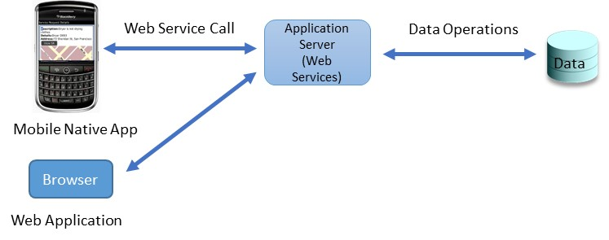

Figure : Before SOA

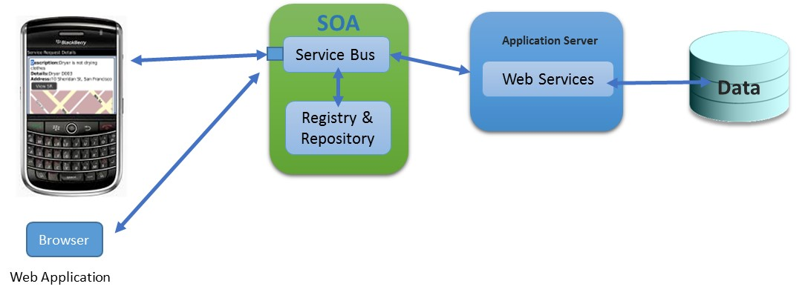

Figure : After SOA

# Repeatable Framework

## Objective

The objective of USPS SOA Mobile Workstream is to develop a Repeatable Framework that can be used by future development teams and architects when deploying web services in the USPS SOA environment. The basis of the framework is an exercise of the IBM SOA tools by developing a small and simple web service and using the knowledge and experience gained as it is configured, integrated and tested through the USPS SOA. This document serves as the basis of the repeatable framework that consists of the following:

1. Web Service Prototype Design and Implementation details
2. IBM DataPower Configuration Guide
3. IBM Websphere Registry and Repository Configuration Guide
4. IBM Integration Bus Configuration Guide
5. USPS SOA Reference Architecture
6. USPS SOA Service Bus Architecture Patterns
7. Points of Contact for USPS SOA Implementation
8. As-Is Web Service Catalog
9. To-Be Web Service Catalog

As-Is and To-Be Web Services Catalog is included to better understand what current and potential and future web services would be hosted in USPS SOA. To-Be web services require further review, vetting and approval from USPS leadership and stakeholders to be implemented. The rest of this document describes the above sections at a minimum to deploy and use the SOA tools.

## Use Case

The general Use Case for applying the Repeatable Framework is to integrate it with an existing governance model. This paper does not address SOA governance but assumes that some level of governance is in place. The example shown is taken from IBM’s *The SOA Governance and Management Method* (SGMM) that shows how the artifacts in the Repeatable Framework can be used within the governance processes. The following highlights an example of how the artifacts can be used:

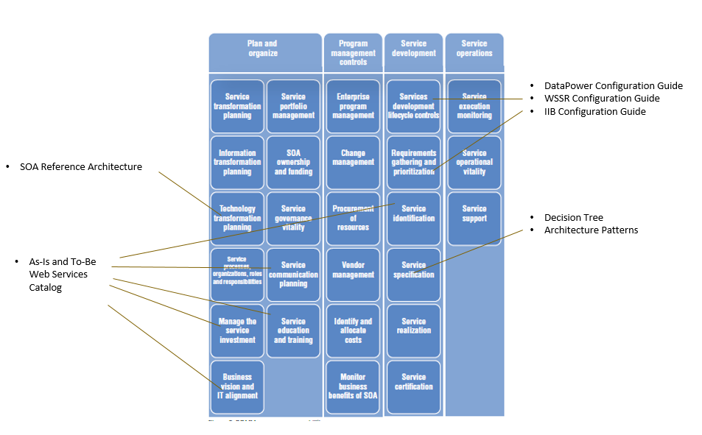

Figure : Example Use Case for how Repeatable Framework can be used within a governance model

## General Implementation Procedures

1. Develop Web Service using SOAP or REST format
2. Determine SOA ESB Architecture to use either DataPower or IIB
3. Install and configure web service in project’s application server for Development, Testing and Deployment
4. Identify Development and Deployment Endpoints from Application Server domain location
5. Contact USPS SOA to configure web service in DataPower, WSRR and/or IIB
6. Get Context ID and Consumer ID from WSRR for Run-time governance
7. Use Context ID and Consumer ID as parameters in client code used when calling web service
8. Work with USPS SOA to configure additional run-time policies
9. Test and configure as necessary
10. Configure DataPower, WSRR and IIB endpoints for deployment to pilot or production

## SOA Configuration and Points of Contact

|  |  |  |  |  |
| --- | --- | --- | --- | --- |
| SOA Component | Input to USPS SOA Team | Output from USPS SOA | Points of Contact | |
| Datapower | 1. Web Service Type: REST vs SOAP 2. WADL for REST or WSDL for SOAP 3. Web Service Endpoints | 1. DataPower URL | * Ted Jump * Rick Pienkowski | Theodore.A.Jump@usps.gov |
| WSSR | DataPower Input | 1. DataPower Output Data 2. Context ID 3. Consumer ID | * Ed Janskaukas | Edward.J.Jankauskas@usps.gov |
| IIB | DataPower Input | 1. IIB URL 2. WSRR Configuration | * Rick Pienkowski * Janet Croft | Richard.Pienkowski@usps.gov |

# Pagination Web Service Prototype

Purpose

* Develop a pilot application to demonstrate a specific web service capability: *A Pagination* web service implemented in a SOA environment. This capability will demonstrate:
  + A Web application as a consumer of the Pagination web service
  + A (simulated) Mobile application as a consumer of the Pagination web service
  + A browser calling the REST based Pagination web service
  + The detailed implementation of the Pagination web service
* The following artifacts will be created in support of governance activities around SOA development:
  + As-Is and To-Be Web Services Catalog
  + SOA-Mobile Design Pattern
  + SOA-Mobile Development Standards
  + SOA-Mobile Reference Architecture
  + Development Infrastructure architecture
  + Agile project plans

## Scope

* An API use case, a Pagination web service, that can be used to implement as the first API on published SOA Infrastructure that can be consumed by Mobile applications (not to restrict just to Mobile – so could also be consumed by non-Mobile). But, the focus here is for Mobile applications. To begin with, this API will be consumed by internal applications only.
* Web Service Requirements:
  + Given a ResultSet, page through it.
  + Input Parameters: ResultSet, Page # for the display page, # of Records per Page.
  + Output Parameters: An array containing records from the ResultSet which are supposed to be displayed on the page for the input parm Page #.
* The web service API should be metadata driven as much as possible and not have key data elements hard-coded, such as:
  + Description of service interface
  + Participants
  + Endpoint and binding information
  + Authorization roles and privileges
  + Consumer / provider relationship

## Methodology, Tools, and Techniques

* Approach:
  + Define specific – small scope goals to accomplish given the 3 month duration.
  + Define high level breakdown of tasks.
  + Discuss how and who to assign each of the high level tasks.
  + Project Management activities – project plan, setup in TMOS / PCTS, understand any other aspects that would need to be monitored, scrum daily call, regular reviews / course correction.
* Agile Backlog grooming:
  + For the backlog (sub-project for SOA Governance and Implementation – Task 6), overall observation has been that previous user stories were at a very high level and could be considered rather an “epic” than a “user story”.
  + That said, take an existing user story as an example and walk AgileX through breaking it up into smaller user stories that can be completed in a 2-week sprint.
  + Define dependencies and prioritization
  + Goal is to make the backlog be in a “usable” state where each user story is defined with a limited scope and is workable in a single sprint.
* Goal is to define a structured / documented and proven way for (repeatable framework):
  + Designing API
  + Building and developing
  + Registering and Publishing
  + Socializing
  + Governance on its use
  + Version management
  + Define standards for data formats, metadata, document format / schemas, etc
* API Management and Governance:
  + First look into what has already been completed as part of last year’s work.
  + Get an inventory of existing services
    - Where the services are located?
      * What services are deployed on what components of SOA Infrastructure?
    - Data Power provides reporting capability on existing services.
    - Understand the capabilities of existing SOA Infrastructure components. Document the capabilities so other teams can understand what component should be used when.
  + Service Consumption
    - External applications consuming the services – likely via SAML
    - Internal applications consuming the services – likely via SSL
    - Billable services – go over a certain threshold for usage – an SLA associated with it. Who will be billable – the consumer app or the service provider app?
    - Manage credentials
    - What are all the steps to get to a web service end-point?
    - Have a presence on ServiceNow to in-take request for publishing a service on SOA Infrastructure.
    - Enforce which services are authorized for consumption based on consumer application roles and privileges.
    - Asynchronous versus synchronous service calls.
  + Service for Mobile device
    - Speed of Network – define controls for payload to prevent delay
    - Prefer to do a RESTful interface versus SOAP
  + Define list of planned services
  + Adoption of services, including, phased transition plan
  + Decision tree to define which components of SOA Infrastructure to use
    - SOA Architecture – define reference architecture to identify which components of SOA Infrastructure would be needed. For example, basic service transformation can be done inside Data Power.
    - For each component of SOA ecosystem, describe how to make them fault-tolerant and Highly Available.
    - Define processes for API management and governance
* The approach for task management, detailed task definition and defined deliverables will use Agile project lifecycle.
* The work to be performed is described in each task below and aligns to the USPS Managed Mobile Strategic Roadmap.
* USPS is requesting a robust adherence to Agile methodology in the execution of these tasks. While Agile may be thought of as more applicable to developing software and code releases we can apply the methodology to the definition, prioritization and completion of the types of deliverables to be performed in this engagement.
* The release schedule for this project will be managed using VersionOne and based on the sprint planning agreed to and managed through Agile methodology.

## Design Overview

The approach is to leverage and adhere to USPS IT Standards, specifically the use of IBM’s technology stack in the development and implementation of this pilot, which includes:

* IBM Websphere Studio for web services
* IBM Worklight Studio for mobile platform and integration

## Design Objective

* Use IBM Websphere development platform to develop and promote consistent development of REST based web services
* Leverage industry best practices, particularly The Open Group Architecture Framework (TOGAF) in the area of SOA design to include design patterns related to web services and SOA
* Leverage IBM’s Websphere components to enable consistent authentication mechanisms, authorization logic, and secure communication.
* Use IBM Worklight Studio to implement and integrate heterogeneous mobile devices and applications that can be used in the SOA infrastructure

## System Architecture

The following use cases have been identified for the Pagination service. The system architecture must be designed to address the unique constraints and risk associated with each profile.

* A browser-based application, e.g. javascript, makes direct requests to the Pagination service. The brower may be internal to the USPS network or requests may travel via the Internet.
* A native mobile application makes direct requests to the Pagination service. Requests will travel via Internet.
* A web application makes server-side requests to the Pagination service.

The following diagram covers use cases one and two. Both mobile and rich browser applications will communicate with the business service to retreive a dataset. Subsequently, both clients will communicate directly with the Pagination service.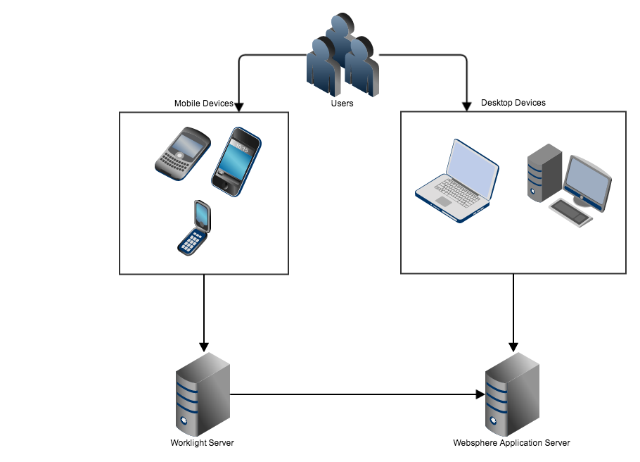

Figure 4 - Logical Architecture

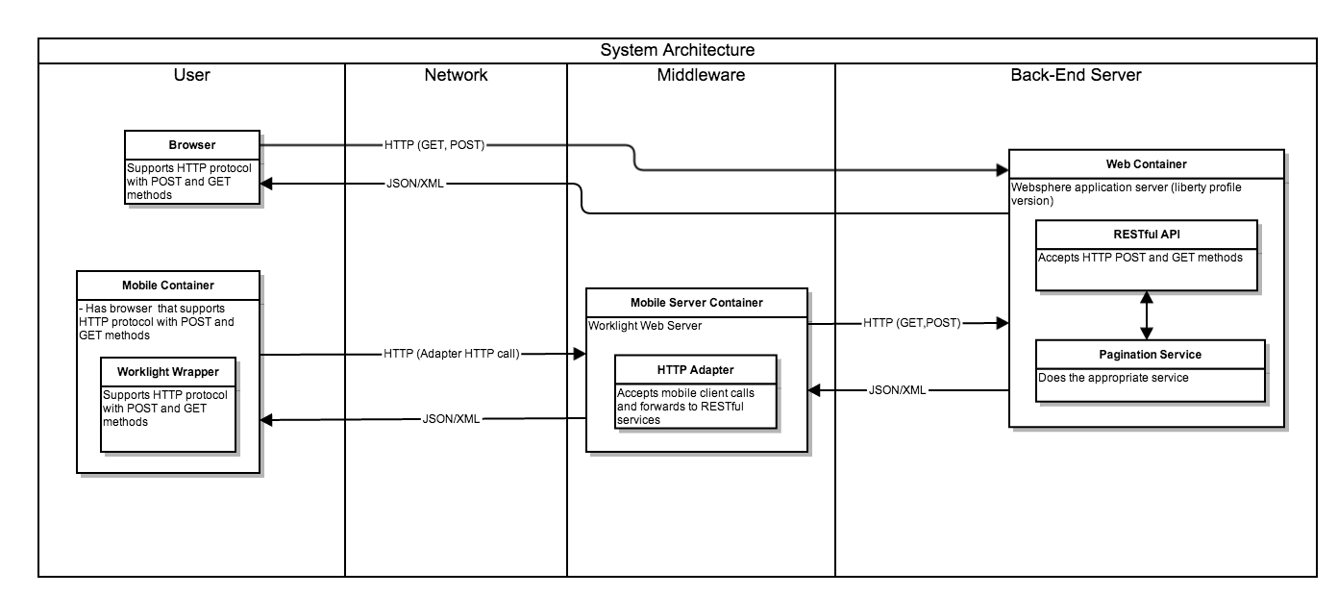

Figure 5 - High Level System Logic Flow

## Software Environment (including Interfaces)

The following shows the software environment used to develop and test with the Pagination RESTful service

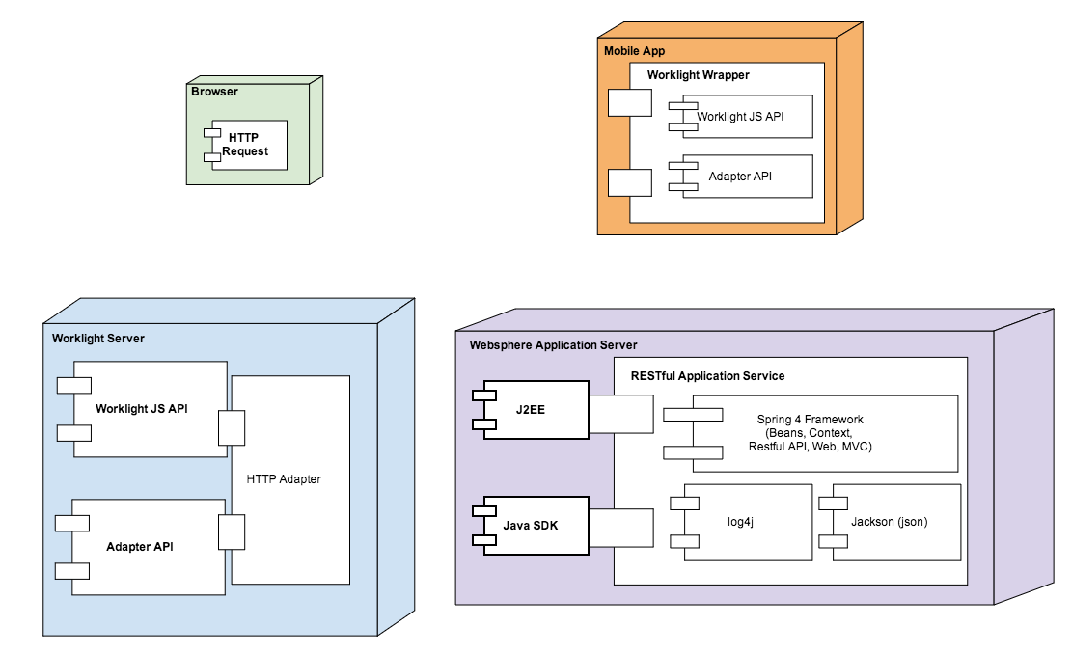

Figure 6 - Software Environment

## Design Constraints

* An Enterprise Service Bus will be not used in the initial pilot implementation
* Service Registry will not be used
* Service Orchestration is not needed and will not be implemented
* Mobile Client Application will be simulated
* Others TBD

## Risks

* Current design is based on requirements for a pilot implementation only. Additional design considerations are needed as new application requirements and/or user stories are added

## Issues

* Access and information on USPS As-Is data may be difficult to get, e.g. existing web services information, planned to-be, etc.

## Assumptions

* Current design is based on requirements for a pilot implementation only

## Performance Requirements

* There are no explicit performance requirements stated for this pilot

## Databases (Oracle, DB2, SQL Server, Other)

**Not Applicable**

## Components List

The following diagram lists all the components in the system

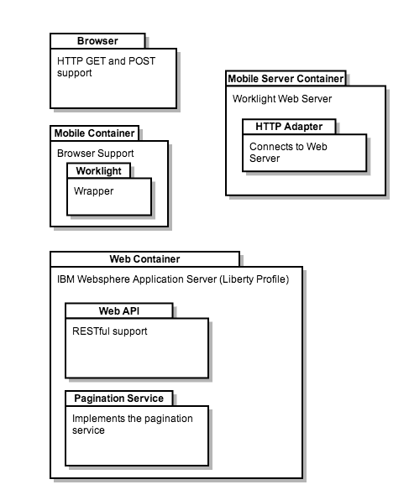

Figure 7 - Software Components

## Component Flow

The following sequence diagram represents the flow of the components through a sequence diagram:

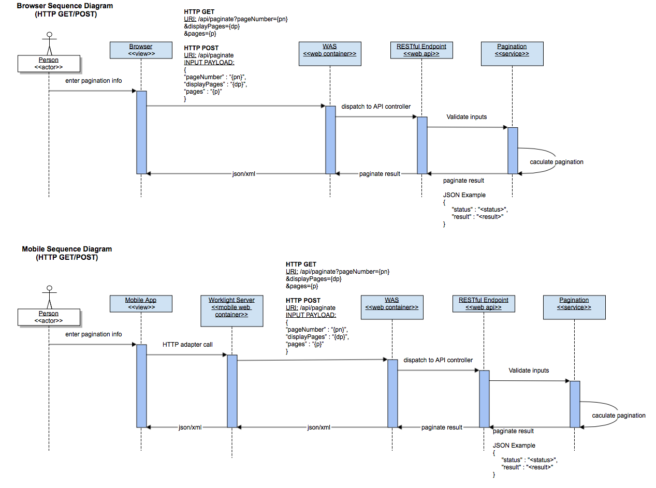

Figure 8 - Component Flow Sequence Diagram

## Supporting Documentation

The table below details of the REST based API calls that will be implemented:

Figure 9 - REST API Call List

|  |  |  |  |
| --- | --- | --- | --- |
| **Resource URI** | **Supported HTTP Methods** | **Description** | **Input Format** |
| /api/paginate?pageNumber={pn}  &displayPages={dp}  &pages={p} | GET | Returns a resultset in JSON/XML of the “pages” payload that are bounded with “pageNumber” and “displayPages” parameters.  This service uses an HTTP GET method, which conforms to the protocol standard rules (e.g. maximum length for parameters). | 1. {pn} – Needs to be an integer greater than zero 2. {dp} – Needs to be an integer greater than zero 3. {p} – String separated with the following formats. There has to be more lines. Needs to be URL encoded. For example…    1. “+” – space    2. “%5Cn” – newline   HTTP Request Headers   1. For result to be in JSON    1. "Accept=application/json" 2. For result to be in XML    1. "Accept=application/xml" |
| /api/paginate | POST | Returns a resultset in JSON/XML of the “pages” payload that are bounded with “pageNumber” and “displayPages” parameters.  This service uses an HTTP POST method, which allows large data communication. | POST Payload  {  “pageNumber” : “{pn}”,  “displayPages” : “{dp}”,  “pages” : “{p}”  }   1. {pn} – Needs to be an integer greater than zero 2. {dp} – Needs to be an integer greater than zero 3. {p} – String separated with the following formats. There has to be more lines. Needs to be URL encoded. For example…    1. “+” – space    2. “%5Cn” – newline   HTTP Request Headers   1. Set the following so the API knows the POST payload is in JSON format.    1. "Content-type=application/json" 2. For result to be in JSON    1. "Accept=application/json" 3. For result to be in XML    1. "Accept=application/xml" |

**Output Format**

An example in JSON format.

{

“status” : “<status>”

“result” : “<result>”

}

1. <status> - “OK”, the service worked properly. “ERROR”, the service encountered problems.
2. <result> - The result from the service. If the <status> was an “ERROR”, this is the error message.

**Example**

Given the following parameters:

displayPages = 5

pageNumber = 4

pages = *** the figure below ***

Given “pages” input payload below, since the parameter “displayPages” is 5, we delineate the payload into page sections by every 5th line, thus giving us a total of 6 pages. Since the “pageNumber” parameter is 4, that’s the result (highlighted below) that will be return to the user.



Figure 10 - Pagination Data Example

## Operational Controls

## Startup and Shutdown

**Application Server Startup**

1. Go to the “bin” folder where Websphere Application/Worklight Server is installed.
2. Do one of the following commands
   1. ./server start <server_name>
      1. Starts the server that is named “server_name” in a new process
   2. ./server run <server_name>
      1. Starts the server that is named “server_name” in the console foreground, this is preferred so that any log information is given to you.
3. Open a browser to check the server is running. Go to the URL <http://localhost:9080/>. You should see the following  
     
   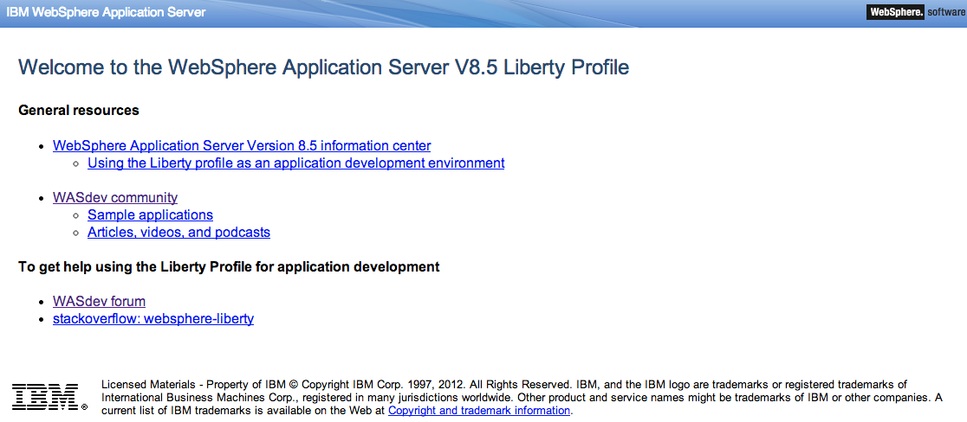  
   1. Server Port
      1. To check what server port you should use, it will be in the following server configuration file “~/usr/servers/<server_name>/server.xml“. Notice the “httpPort” attribute.  
           
         

**Application Server Shutdown**

1. Go to the “bin” folder where Websphere Application/Worklight Server is installed.
2. If you started the server with the following command “./server start <server_name>”, do the following command to stop the server “./server stop <server_name>”

If you started the server with the following command “./server run <server_name>”, do the following command to in the Terminal window that is running the server “Ctrl + C”. You can also do the following as well in another terminal window “./server stop <server_name>”

## Audit and Recovery

**NOT APPLICABLE**

## Restart

Application Servers will be restarted through console applications provided by product vendor and accessed with administrative privileges

## Backup Strategy

**NOT APPLICABLE**

## Fallback Strategy

**NOT APPLICABLE**

## Security/Compliance Design Strategies

### Operating System–Level Security Strategy

Access and Authorization controls will be based on security profiles created in USPS and Agilex development environments:

* Agilex:

Access to application and web service will be granted to specific public IP addresses

Access to Virtual Machine instance is limited to administrator authenticated with assigned user IDs and passwords

Access protocols will be limited to SSH, HTTP and HTTPS

* USPS will adhere to USPS security protocols as required when system is deployed in USPS DEV and SIT environments

### Database-Level Security Strategy

**NOT APPLICABLE – database not used in current design**

[Describe how the system requirements will be met.]

* Will eAccess be used? [Indicate whether eAccess will be used.]
* How will you insure database IDs will have the minimal authorization they need to perform the functions that are required? [Describe how database IDs will have the minimal authorization they need to perform required functions.]

### Application-Level Security Strategy

[Describe how the system requirements will be met.]

Describe the strategies for:

* User authorization:
* User access:
* Web service authorization:
* Web service access:

# IBM DataPower

## Overview

This document provides instructions for how to get an API registered in the IBM WebSphere DataPower appliance.

* The instructions use a Pagination Service API as a Use Case to show example for each step. The Pagination Service API is used for demonstration purpose only, and, currently, does not have address to a specific business need.
* The example used here shows calling an API using HTTP POST method.

## API Definition

## Input

A typical API configuration request for DataPower would need the following data:

1. Resource URI
2. Supported HTTP methods – POST or GET
3. Response
4. Description of the API call

For Example,

The POST definition is detailed below. For complete definition (parameter values, HTTP header options, etc.) of the POST method, please refer to Appendix A1.

|  |  |  |  |
| --- | --- | --- | --- |
| **Resource URI** | **Supported HTTP Methods** | **Response** | **Description** |
| /api/paginate | POST | JSON:  {  “status” : “[status]”  “results” : “[result]”  }  XML:  <paginateResponse>  <status>[status]</status>  <results>[result]</results>  <results>[result]</results>  .  .  </paginateResponse> | Returns a resultset in JSON/XML of the “pages” payload that are bounded with “pageNumber” and “displayPages” parameters.  This service uses an HTTP POST method, which allows large data communication. |

For the GET definition, please refer to the Appendix A2.

## Request

The POST request method will need the following parameters:

1. **URL endpoint** – The URL endpoint to access the REST service provider

* http://eagnmnmbd19c.usps.gov:9080/soaPagination_producer/api/paginate

1. **HTTP Method** – The HTTP method type for the communication

* POST

1. **Data Type** – The input format type

* json

1. **Content Type** – The response format type

* json

1. **Data** – The input data

* Example
  + {

"pageNumber" : "4",

"displayPages" : "5",

"pages" : [

"1",

"2",  
"3"]

}

## Response

Both POST and GET methods for calling the web service will return the same result in JSON/XML format.

JSON example format:

{

“status” : “[status]”

“results” : “[results]”

}

XML example format:

<paginateResponse>

<status>[status]</status>

<results>[result]</results>

<results>[result]</results>

.

.

</paginateResponse>

JSON/XML format definitions:

* [status] - “OK”, the service worked properly. “ERROR”, the service encountered problems.
* [result] - The result from the service. If the <status> was an “ERROR”, this is the error message.
* [results] – The result in a JSON format. Essentially this will be an array of [result] values (e.g. [“1”,”2”,”3”]).

## Configure DataPower

DataPower needs to be configured with a Multi-Protocol Gateway to pass incoming requests for the API to the target endpoint on WebSphere Application Server.

For Example,

The target endpoint for the Pagination service is:

<http://eagnmnmbd19c.usps.gov:9080/soaPagination_producer/api/paginate>

The following configuration is for DataPower to pass-through requests to the Pagination service. There are multiple ways to configure a “pass-through”. The following is one example.

* **Multi-Protocol Gateway Name:** PaginationServiceMPGW
* **Multi-Protocol Gateway Policy:** default
* **Type:** static-backend
* **Backend URL:** http://eagnmnmbd19c.usps.gov:9080
* **Request Type:** Pass-Thru
* **Response Type:** Pass-Thru
* **Navigate to…** Local Endpoint Hander -> Front Side Protocol -> HTTP Front Side Handler
  + **Front Side Handler Name:** PaginationServiceFSH
  + **Allowed Methods and Versions:** select GET method and POST method

For Example,

To configure the front side handler using port 81, please look at Figure 1.

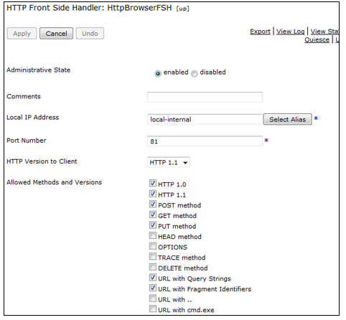

Figure : DataPower front side configurations

For Example,

To map the back-end to a static URL (e.g. http://eagnmnmbd19c.usps.gov:9080) where the provider application server is, please look at Figure 2.

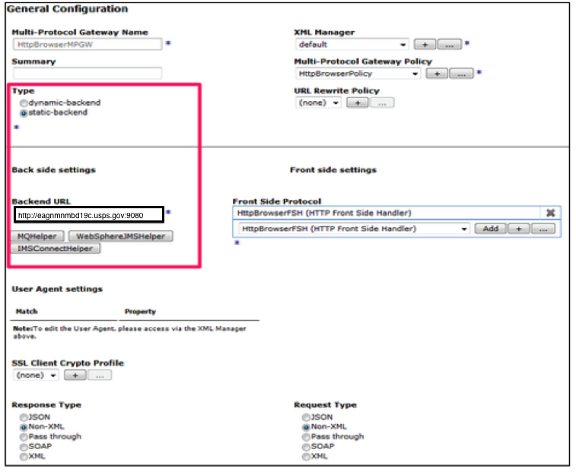

Figure : DataPower back side configurations

## Test

To test the Pagination Service using DataPower as the gateway (pass-through), enter the following URL format in a browser.

**Format**

https://ddatapower.usps.gov:443/soaPagination_producer/api/paginate? json={“pageNumber” : “{pn}”, ”displayPages” : “{dp}” ,”pages” : {p}}

**Example Values**

https://ddatapower.usps.gov:443/soaPagination_producer/api/paginate? json={“pageNumber” : “1”, ”displayPages” : “2” ,”pages” : [“1”, “2”, “3”, “4”, “5”, “6”, “7”, “8”, “9”]}

## Configure Consumer Application

### Configuration

The consumer web page application allows the user to specify the REST service URL endpoint.

To specify the REST Service URL Endpoint for the consumer web page application, just enter the REST service URL endpoint in the textbox provided, as shown in Figure 3.

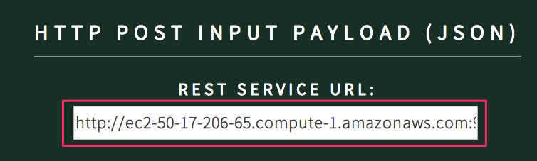

http://eagnmnmbd19c.usps.gov:9080/soaPagination_provider/api/paginate

Figure : Consumer application configuration for REST URL endpoint

## Example

The following is a definition list for the diagrams in this section.

* WAS
  + WebSphere Application Server
* Consumer
  + Web application rendering static content
* Provider
  + REST based service

Figure 4 is an example diagram of the **“before”** architecture of how the consumer web application operates in a development environment.

* Consumer web app directly calls REST API of the Provider app.

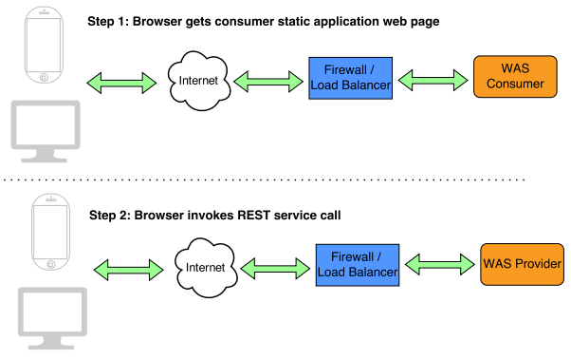

Figure : "Before" architecture example for consumer application

Figure 5 is an example diagram of the **“after”** architecture of how the consumer web application operates in an USPS environment.

* Consumer web app calls Data Power to route call to REST API of the Provider app.

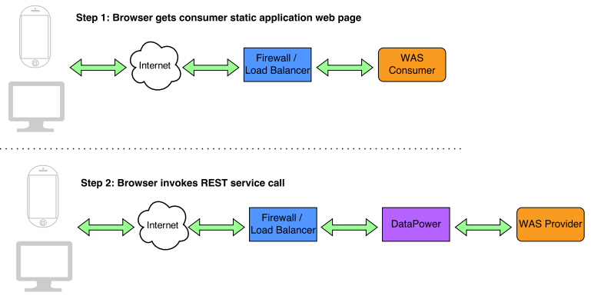

Figure : "After" architecture example for consumer application

## Appendix

### POST API Complete Definition

**POST method - /api/paginate**

* **POST Payload**

{

“pageNumber” : “{pn}”,

“displayPages” : “{dp}”,

“pages” : {p}

}

* + {pn} – Needs to be an integer greater than zero
  + {dp} – Needs to be an integer greater than zero
  + {p} – An array of values. Example format…
    - [“1”,”2”,”3”]
* **HTTP Request Headers**
  + Set the following so the API knows the POST payload is in JSON format.
    - "Content-type=application/json"
  + For result to be in JSON
    - "Accept=application/json"
  + For result to be in XML
    - "Accept=application/xml"

### GET API Definition

|  |  |  |  |
| --- | --- | --- | --- |
| **Resource URI** | **Supported HTTP Methods** | **Response** | **Description** |
| /api/paginate?json={“pageNumber” : “{pn}”, ”displayPages” : “{dp}”  ,”pages” : {p}} | GET | JSON:  {  “status” : “[status]”  “results” : “[result]”  }  XML:  <paginateResponse>  <status>[status]</status>  <results>[result]</results>  <results>[result]</results>  .  .  </paginateResponse> | Returns a resultset in JSON/XML of the “pages” payload that are bounded with “pageNumber” and “displayPages” parameters.  This service uses an HTTP GET method, which conforms to the protocol standard rules (e.g. maximum length for parameters). |

**GET method**

* **/api/paginate?json={“pageNumber” : “{pn}”, ”displayPages” : “{dp}” ,”pages” : {p}}**
  + {pn} – Needs to be an integer greater than zero
  + {dp} – Needs to be an integer greater than zero
  + {p} – An array of values. Example format…
    - [“1”,”2”,”3”]
* **HTTP Request Headers**
  + For result to be in JSON
    - "Accept=application/json"
  + For result to be in XML
    - "Accept=application/xml"
* **For JSON result in URL (Note the difference in highlighted text)**
  + /api/paginate.json?json={“pageNumber” : “{pn}”, ”displayPages” : “{dp}” ,”pages” : {p}}
* **For XML result in URL (Note the difference in highlighted text)**
  + /api/paginate.xml?json={“pageNumber” : “{pn}”, ”displayPages” : “{dp}” ,”pages” : {p}}

# IBM Websphere Service Registry and Repository

## Purpose

This guide describes the steps to configure and view the Service Catalog in IBM’s Websphere Service Registry and Repository 8.5 (WSRR). The Service Catalog is the central catalog for services where all services can be searched and understood in terms of its governance and registration functions, the stage the services are in, its users, policies, and other related metadata. The following steps are validated against WSRR 8.5 (trial edition) running on Websphere Application Server (WAS) 8.5.5 (trial edition).

## Configuring a Service Catalog in WSRR 8.5

A Service Catalog view comes preconfigured in WSRR as of version 8.5. The view does not include REST service endpoints by default. The following steps describe how to update the default view to include REST service endpoints.

1. Open up Service Registry Dashboard. Login with your Administrator credentials and click “Log in”.

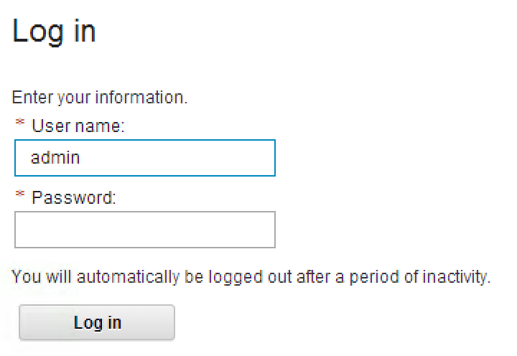

Figure - Log In screen

1. Select the Service Catalog view in the view dropdown.

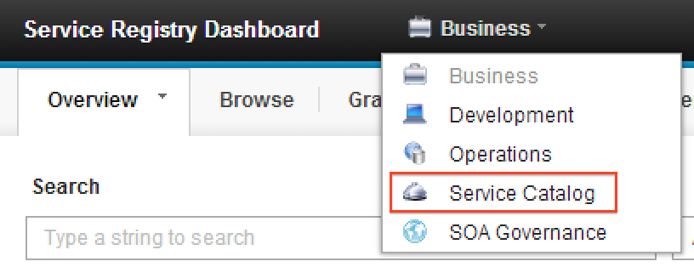

Figure - Service Catalog Menu

1. The default service catalog view is displayed. Click the menu dropdown on the Find a Service tab.

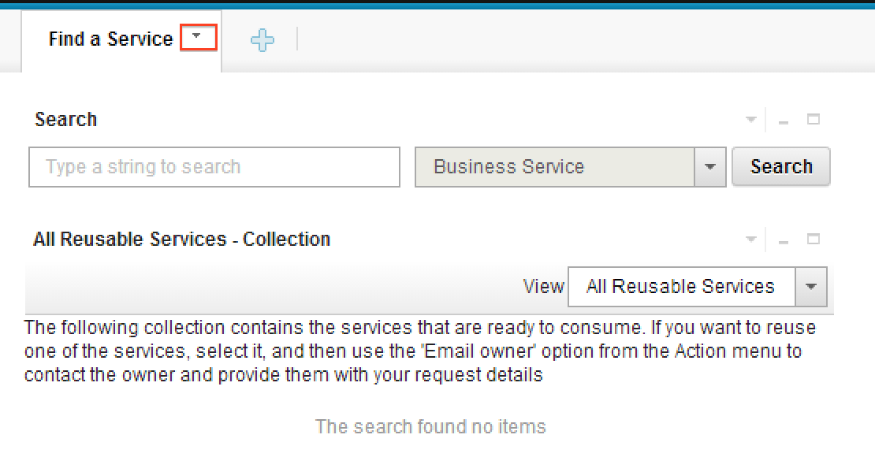

Figure - Service Catalog View

1. On the “Find a Service” tab, click “Edit Page…”

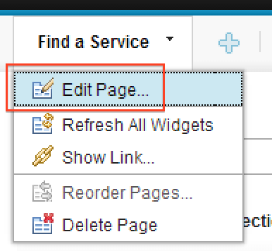

Figure - Edit Page menu option

1. On the “Search” widget, click “Edit Settings…”

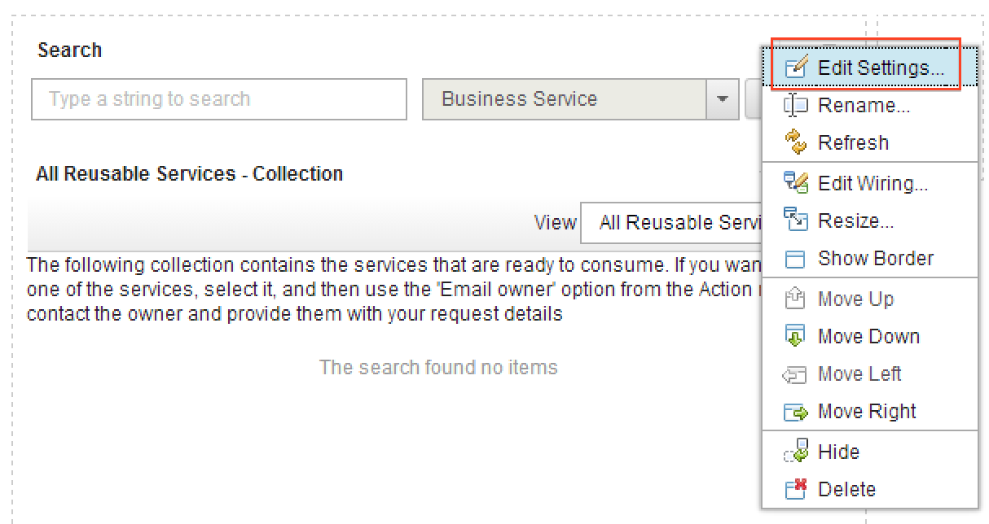

Figure - Edit Settings menu option

1. Scroll back up and select “All Listed Types” as the default filter. Note: it won’t include REST Service Endpoint as an optional default until after it is selected in the next step.

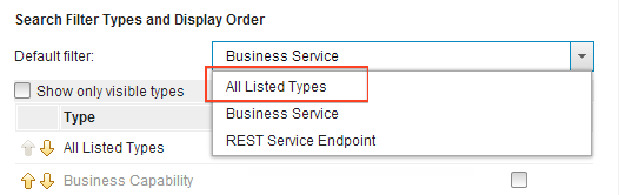

Figure - All Listed Types menu option

1. Scroll down and select the checkbox next to “REST Service Endpoint”. Then click “Save and Close”.

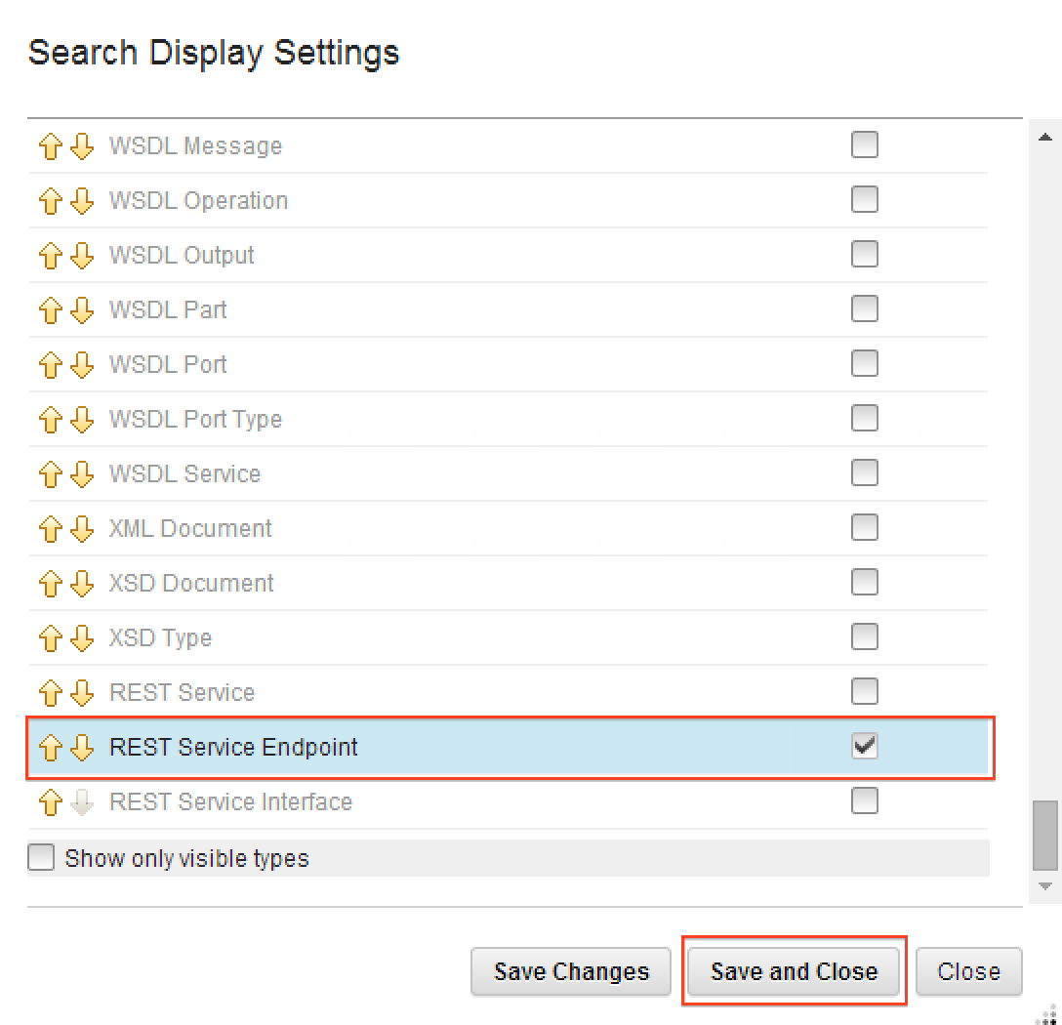

Figure - Search Display Settings

1. Click “Finish”



Figure - Finish editing page button

1. Note the informational message: “The page was changed successfully.”

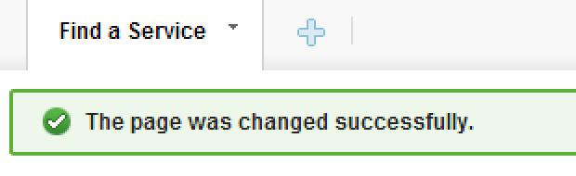

Figure - Edit Confirmation

1. Click “Search”

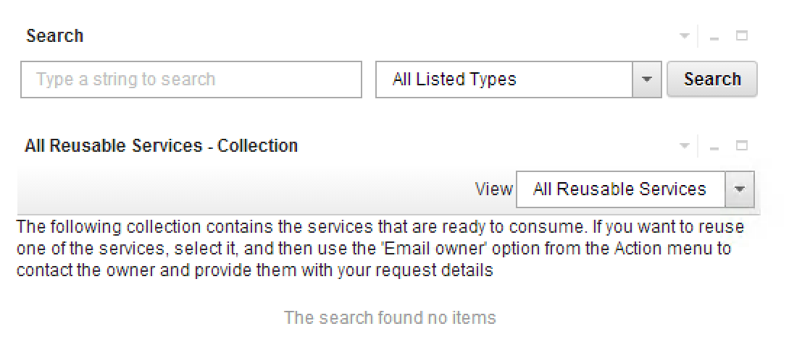

Figure - Search Catalog

1. Note the REST services are displayed. Click on a REST service

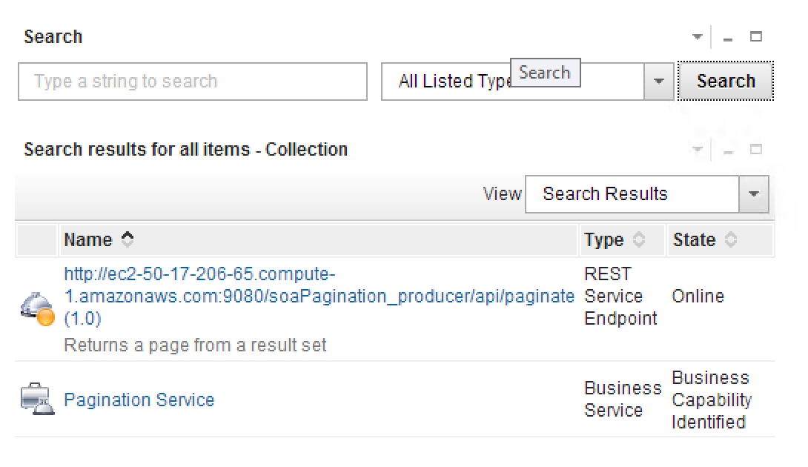

Figure - Catalog View with REST Services

1. Note the REST service details are displayed in the Service Detail widget.

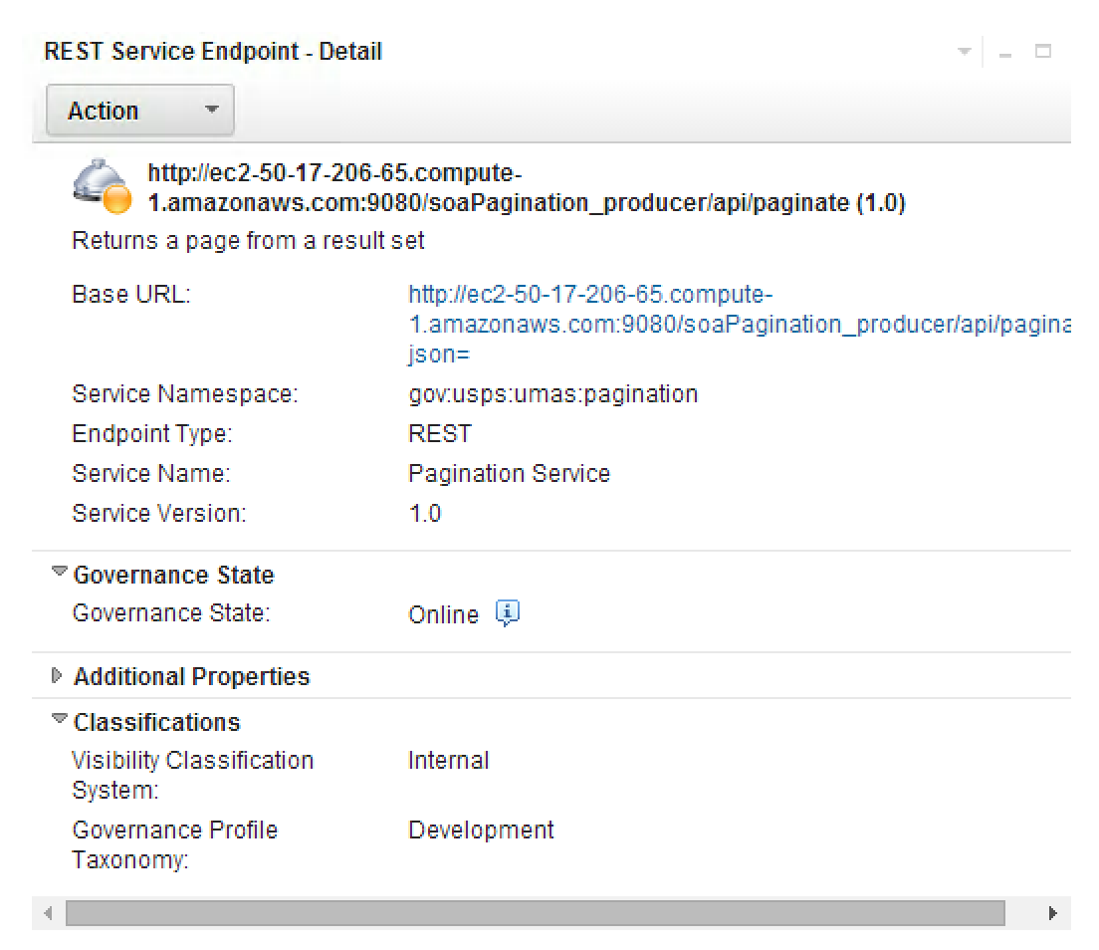

Figure - REST Endpoint Detail

## Exporting a Service Catalog in WSRR 8.5

1. Open up WSRR Console. Login with your Administrator credentials and click “Log in”.
2. Click the “Home” tab.

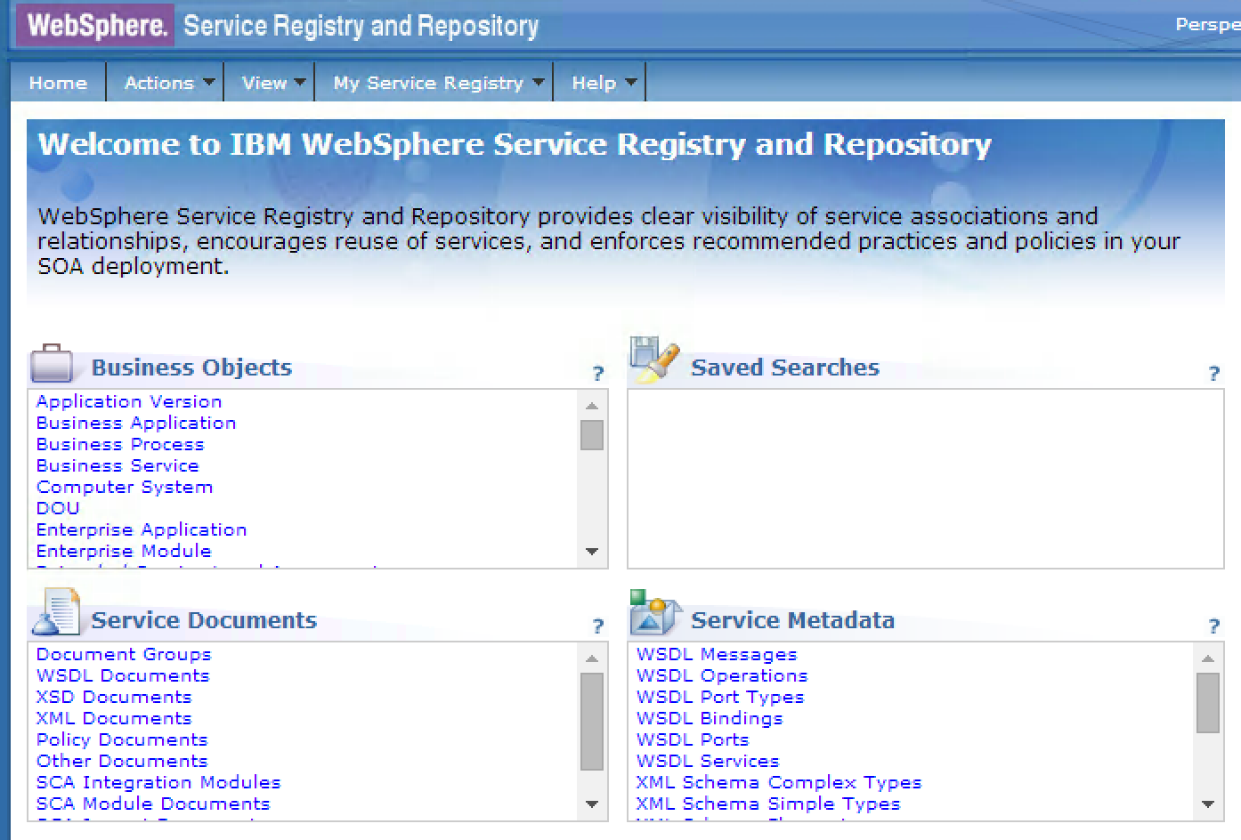

Figure - WSSR Console Home page

1. Select “REST Service Endpoint” from the Business Objects selection box.

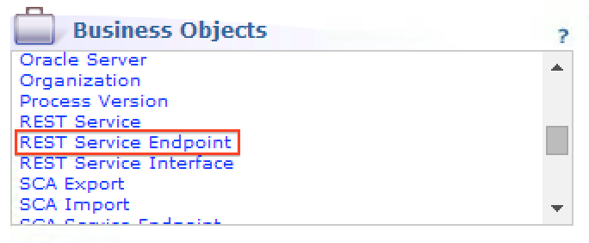

Figure - Business Object Selection box

1. Select all items and click “Export”.

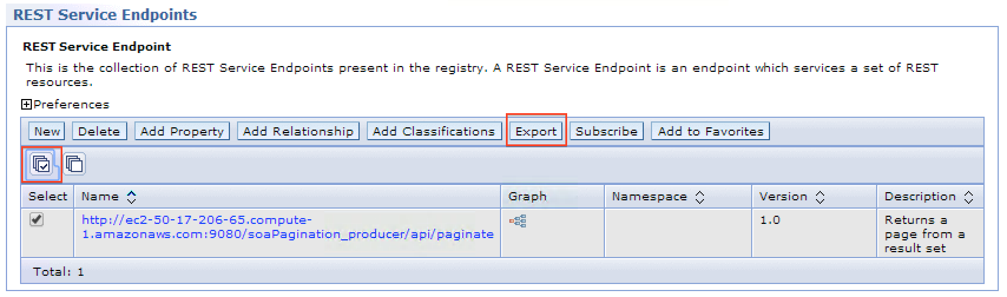

Figure - REST Service Endpoint view

The following is an example of the exported formatting of a REST Endpoint.



Figure - Export file

# IBM DataPower and Websphere Registry and Repository

This document provides instructions for how to get an API registered in the IBM WebSphere DataPower appliance and IBM Websphere Registry and Repository (WSRR).

* The instructions use a Pagination Service API as a Use Case to show example for each step. The Pagination Service API is used for demonstration purpose only, and, currently, does not have address to a specific business need.
* The example used here shows calling an API using HTTP POST method.

## API Definition

### Input

A typical API configuration request for DataPower would need the following data:

* Resource URI
* Supported HTTP methods – POST or GET
* Response
* Description of the API call

For Example,

The POST definition is detailed below. For complete definition (parameter values, HTTP header options, etc.) of the POST method, please refer to Appendix A1.

|  |  |  |  |
| --- | --- | --- | --- |
| **Resource URI** | **Supported HTTP Methods** | **Response** | **Description** |
| /api/paginate | POST | JSON:  {  “status” : “[status]”  “results” : “[result]”  }  XML:  <paginateResponse>  <status>[status]</status>  <results>[result]</results>  <results>[result]</results>  .  .  </paginateResponse> | Returns a resultset in JSON/XML of the “pages” payload that are bounded with “pageNumber” and “displayPages” parameters.  This service uses an HTTP POST method, which allows large data communication. |

For the GET definition, please refer to the Appendix A2.

## Request

The POST request method will need the following parameters:

1. **URL endpoint** – The URL endpoint to access the REST service provider

* http://eagnmnmbd19c.usps.gov:9080/soaPagination_provider/api/paginate

1. **HTTP Method** – The HTTP method type for the communication

* POST

1. **Data Type** – The input format type

* json

1. **Content Type** – The response format type

* json

1. **Data** – The input data

* Example
  + {

"pageNumber" : "4",

"displayPages" : "5",

"pages" : [

"1",

"2",  
"3"]

}

## Response

Both POST and GET methods for calling the web service will return the same result in JSON/XML format.

JSON example format:

{

“status” : “[status]”

“results” : “[results]”

}

XML example format:

<paginateResponse>

<status>[status]</status>

<results>[result]</results>

<results>[result]</results>

.

.

</paginateResponse>

JSON/XML format definitions:

* [status] - “OK”, the service worked properly. “ERROR”, the service encountered problems.
* [result] - The result from the service. If the <status> was an “ERROR”, this is the error message.
* [results] – The result in a JSON format. Essentially this will be an array of [result] values (e.g. [“1”,”2”,”3”]).

## Configure WSRR

To configure a web service n WSRR, a project team must submit the following information:

1. Business use case definition
   * In TeamTrack – WB-SOA project. Following data elements need to be provided:
   1. A name for the web service
   2. A description for the web service
   3. A name for the consumer application
   4. A name for the consumer organization
   5. A name for the provider organization
   6. For the Service Level Definition (SLD):
      * Availability (24/7 default)
      * Response Time (300 milliseconds default)

The link for TeamTrack item, which will serve as the Charter needs to be emailed to the WB-SOA team.

1. Create Service Definition file
   * A Web Service Description Language (WSDL) file for a SOAP based service
     + For example … see appendix as an example
   * A Web Application Definition Language (WADL) file for a REST based service
2. Context and Consumer IDs from WSRR registration
   * WB-SOA team will generate unique IDS for context and consumer IDs
   * Context ID is related to the Service Level Agreement (SLA), i.e. relationships between consumer and provider
   * Consumer ID is related to the consumer application

Talk about the SLA and SLD….

Generating a Application version - consumer ID

SLD – endpoint

SLA - context ID

Register a REST service with WSSR so that SOA system components (e.g. DataPower) can subscribe to the service. The following are parameters that need to be set in WSRR to register the Pagination Service. Refer to Appendix A3 for a step-by-step guide on how to register a REST service with WSRR.

1. **Name:** http://eagnmnmbd19c.usps.gov:9080/soaPagination_provider/api/paginate
2. **Description:** Accepts a result set, target page and page size and returns a page.
3. **Environment:** Development.
4. **Visibility:** Internal
5. **Version:** 1.0
6. **Base URL:** http://eagnmnmbd19c.usps.gov:9080/soaPagination_provider/api/paginate
7. **Service Namespace:** gov:usps:soa:pagination
8. **Endpoint Type:** REST
9. **Service Name:** Pagination Service
10. **Service Version:** 1.0

## Configure DataPower

Multi-Protocol Gateway

The following configuration will show how to create a proxy (Multi-Protocol Gateway) in DataPower that takes a REST service endpoint from WSRR and routes it to the real service.

This section assumes that the DataPower has already been configured to connect to the WSRR server. If not, please refer to Appendix A4 for the appropriate instructions on how to set that up.

The following information is based on an article found in Appendix A6. The article was authored using both DataPower V5/V6 and WSSR 8.0.0.2. The instructions for a multi-protocol gateway are broken in two steps.

1. Create service proxy
2. Subscribe REST service from WSRR

### Create Service Proxy

1. **Multi-Protocol Gateway Name:** PaginationServiceMPGW
2. **Multi-Protocol Gateway Policy:** default-accept-service-providers
3. **Type:** dynamic-backends
4. **Request Type:** JSON
5. **Response Type:** JSON/XML
6. **Navigate to…** Local Endpoint Hander -> Front Side Protocol -> HTTP Front Side Handler
   1. **Front Side Handler Name:** PaginationServiceFSH
   2. **Allowed Methods and Versions:** select GET method and POST method

### Subscribe REST service from WSRR

1. **WSSR Subscription Name (New):** PaginationService
2. **Synchronization Method:** Automatic (WSSR 7.5 or later)
3. **Subscription Object:** Service Version
4. **Object Name:** Pagination Service
5. **Namespace:** [empty]
6. **Object Version (on):** 1.0
7. **Advanced:** Process Messages Whose Body is Empty: On

## Test

To test the Pagination Service using DataPower as the gateway (pass-through), enter the following URL format in a browser.

**Format**

https://ddatapower.usps.gov:443/soaPagination_provider/api/paginate? json={“pageNumber” : “{pn}”, ”displayPages” : “{dp}” ,”pages” : {p}}

**Example Values**

https://ddatapower.usps.gov:443/soaPagination_provider/api/paginate? json={“pageNumber” : “1”, ”displayPages” : “2” ,”pages” : [“1”, “2”, “3”, “4”, “5”, “6”, “7”, “8”, “9”]}

## Configure Consumer Application

The consumer web page application allows the user to specify the REST service URL endpoint.

To specify the REST Service URL Endpoint for the consumer web page application, just enter the REST service URL endpoint in the textbox provided, as shown in Figure 1.



Figure : Consumer application configuration for REST URL endpoint

For Example,

The following is a definition list for the diagrams in this section.

* WAS
  + Websphere Application Server
* Consumer
  + Web application rendering static content
* Provider
  + REST based service

Figure 2 is an example diagram of the **“before”** architecture of how the consumer web application operates in a development environment.

* Consumer web app directly calls REST API of the Provider app.



Figure : "Before" architecture example for consumer application

Figure 3 is an example diagram of the **“after”** architecture of how the consumer web application operates in an USPS environment.

* Consumer web app calls Data Power to route call to REST API of the Provider app.

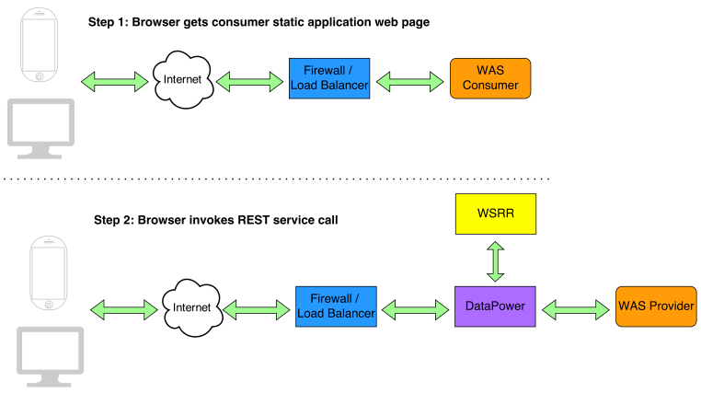

Figure : "After" architecture example for consumer application

## Appendix

### POST API Complete Definition

**POST method - /api/paginate**

* **POST Payload**

{

“pageNumber” : “{pn}”,

“displayPages” : “{dp}”,

“pages” : {p}

}

* + {pn} – Needs to be an integer greater than zero
  + {dp} – Needs to be an integer greater than zero
  + {p} – An array of values. Example format…
    - [“1”,”2”,”3”]
* **HTTP Request Headers**
  + Set the following so the API knows the POST payload is in JSON format.
    - "Content-type=application/json"
  + For result to be in JSON
    - "Accept=application/json"
  + For result to be in XML
    - "Accept=application/xml"

### GET API Definition

|  |  |  |  |
| --- | --- | --- | --- |
| **Resource URI** | **Supported HTTP Methods** | **Response** | **Description** |
| /api/paginate?json={“pageNumber” : “{pn}”, ”displayPages” : “{dp}”  ,”pages” : {p}} | GET | JSON:  {  “status” : “[status]”  “results” : “[result]”  }  XML:  <paginateResponse>  <status>[status]</status>  <results>[result]</results>  <results>[result]</results>  .  .  </paginateResponse> | Returns a resultset in JSON/XML of the “pages” payload that are bounded with “pageNumber” and “displayPages” parameters.  This service uses an HTTP GET method, which conforms to the protocol standard rules (e.g. maximum length for parameters). |

**GET method**

* **/api/paginate?json={“pageNumber” : “{pn}”, ”displayPages” : “{dp}” ,”pages” : {p}}**
  + {pn} – Needs to be an integer greater than zero
  + {dp} – Needs to be an integer greater than zero
  + {p} – An array of values. Example format…
    - [“1”,”2”,”3”]
* **HTTP Request Headers**
  + For result to be in JSON
    - "Accept=application/json"
  + For result to be in XML
    - "Accept=application/xml"
* **For JSON result in URL (Note the difference in highlighted text)**
  + /api/paginate.json?json={“pageNumber” : “{pn}”, ”displayPages” : “{dp}” ,”pages” : {p}}
* **For XML result in URL (Note the difference in highlighted text)**
  + /api/paginate.xml?json={“pageNumber” : “{pn}”, ”displayPages” : “{dp}” ,”pages” : {p}}

### How to register a REST service in WSSR

The following steps are validated against WSRR 8.5 (Trial Edition) running on WAS 8.5.5 (Trial/Evalation Edition).

1. Open up Service Registry Dashboard. Login with your Administrator credentials and click “Log in”.  
     
   
2. Ensure the “Overview” tab is selected and then select Operations view in the dropdown.  
     
   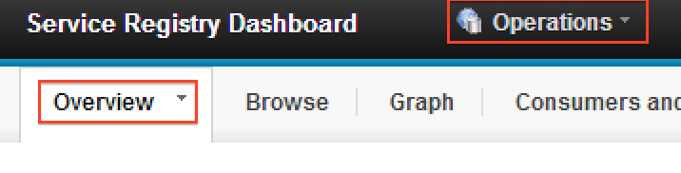
3. Click “Create a REST Service Endpoint” from the Actions widget.  
     
   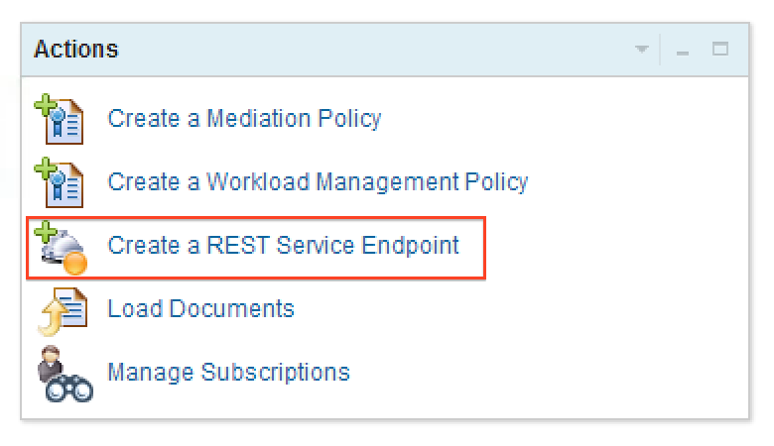
4. In the “Create a REST Service Endpoint” wizard, fill in the following information and click “Finish”. For example inputs for the parameters, refer to the above document section “Configure WSSR”.  
     
   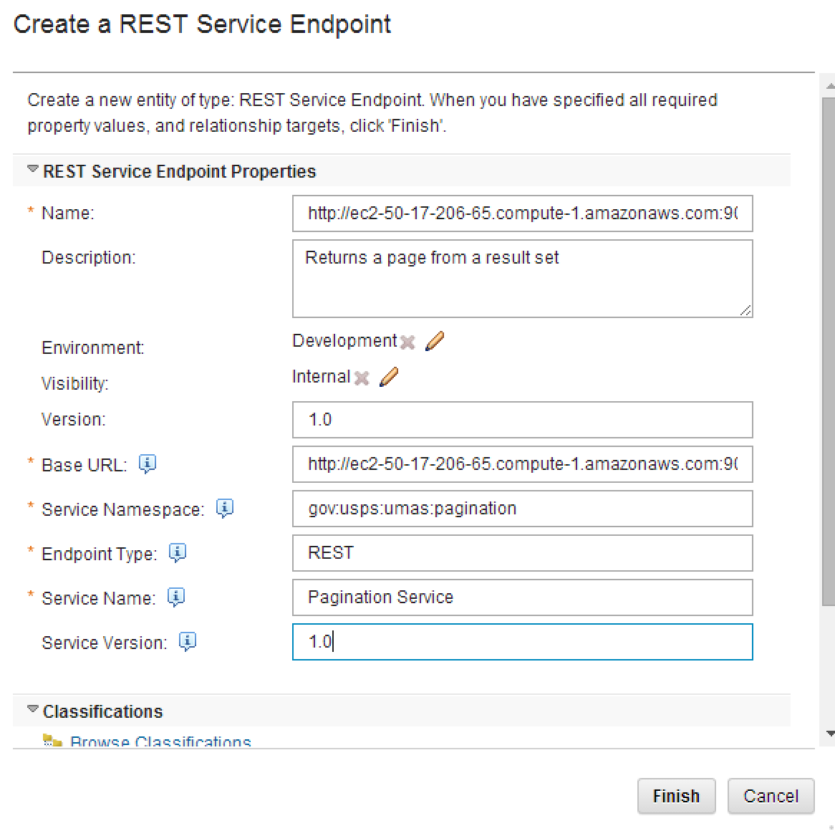
5. The REST Service Endpoint Detail will be displayed. Note that the service Governance State is “Offline”.  
     
   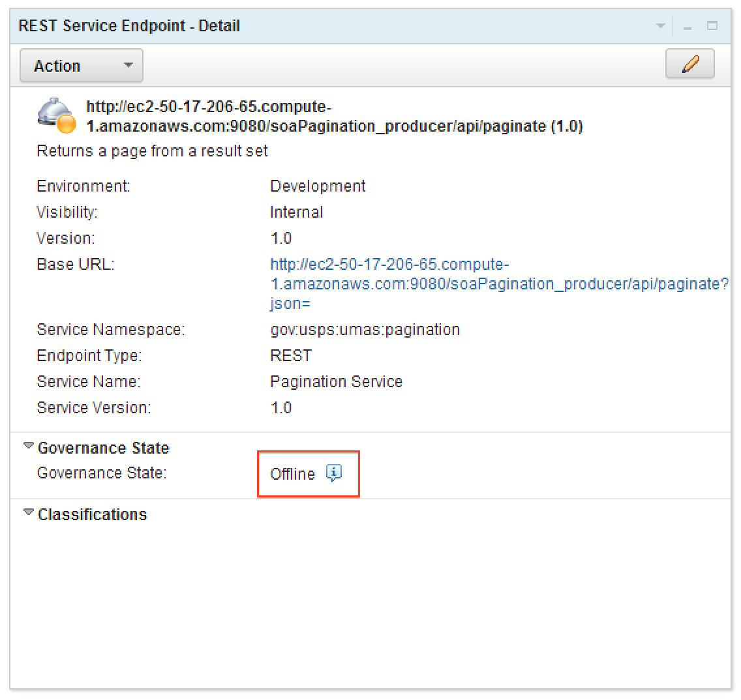
6. From the action menu, select “Approve for Use”.  
     
   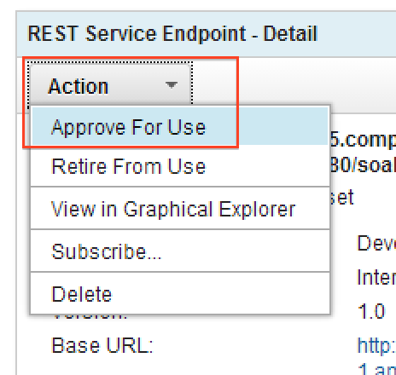
7. Note that the service Governance State is now “Online”.  
     
   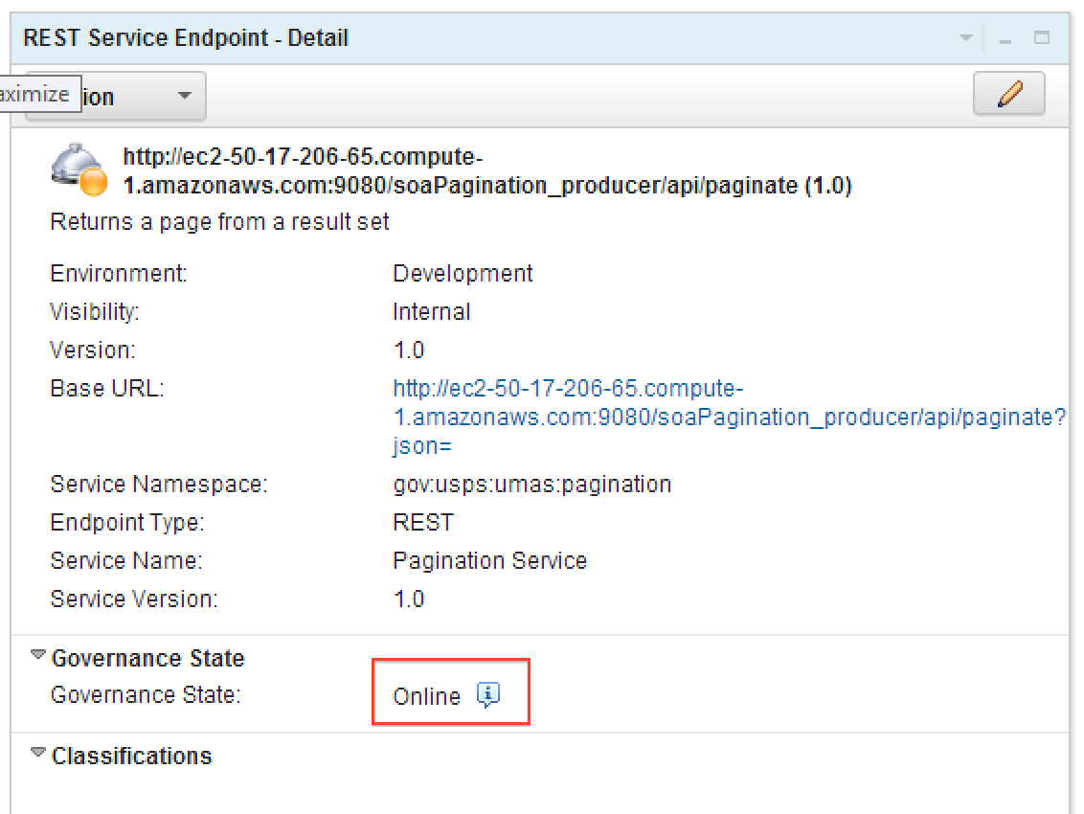

### Register WSSR server in DataPower

The purpose of this section is to setup connectivity between DataPower and WSRR server. The following instructions will achieve that goal. The instructions are broken in two parts.

1. Create an SSL Proxy Profile for WSRR in DataPower

* Establishes an SSL communication between DataPower and WSRR.

1. Configure WSRR server connection in DataPower

* Tell DataPower where the WSRR server is residing in the network.

### Creating an SSL Proxy Profile for WSSR in DataPower

#### Save a Copy of WSRR’s Public SSL Certificate

1. Using a Firefox (confirmed with v29.0.1) browser, navigate to the WSRR Dashboard.
2. Click on the lock icon next to “https” in the browser’s URL field.
3. Click “More Information…” button
4. Click “View Certificate” button
5. Click “Details” tab
6. Click “Export…”
7. Save as “WSRR-Server-SSL-Certificate” in format X.509 Certificate with chain (PEM)

#### Store the WSRR Public Certificate in DataPower

1. Login into DataPower as an administrator.
2. Click “File Management”
3. Upload the WSRR-Server-SSL-Certificate.pem file to the “cert” folder.

#### Create Crypto Certificate

1. Using Search, navigate to the Crypto Certificate page.
2. Click “Add”
3. Name: wsrr-server-ssl-certificate
4. Filename: choose “cert:///” folder and WSRR-Server-SSL-Certificate.pem
5. Accept remaining default values
6. Click Apply
7. Note “[up]”

#### Create Crypto Validation Credentials

1. Using Search, navigate to the Crypto Validation Credentials page.
2. Click “Add”
3. Name: wsrr-server-validation-credentials
4. Certificate: wsrr-server-ssl-certificate
5. Accept remaining default values
6. Click Apply
7. Note “[up]”

#### Create SSL Proxy Profile

1. Using Search, navigate to the SSL Proxy Profile page.
2. Click “Add”
3. Name: wsrr-server-proxy-profile
4. SSL Direction: Forward
5. Forward (Client) Crypto Profile:
   1. Name: wsrr-client-ssl-crypto-profile
   2. Validation Credentials: wsrr-server-validation-credential
   3. Accept remaining default values
   4. Apply
6. Accept remaining default values
7. Apply
8. Note “[up]”
9. Click “Save Configuration” (top right)

### Configure WSRR Server Connection in DataPower

1. Using Search, navigate to the WSRR Server configuration page.
2. Click “Add”
3. Name: wsrr-sandbox
4. Administrative State: enabled
5. SOAP URL: [TBD]
6. SSL Proxy Profile: wsrr-server-proxy-profile (or existing)
7. Username:
8. Password:
9. WSRR Server Version: 7.5 or later

### Using DataPower with WSRR and REST services

The article was authored using both DataPower V5 and V6 and WSSR 8.0.0.2

<http://www.ibm.com/developerworks/websphere/library/techarticles/1311_seager/1311_seager.html>

# IBM Integration Bus

The following steps are validated against IIB 9.0.0.2 running on MQ 7.5.

In MQ Explorer, right-click on *Queue Manager*, select *New* and *Queue Manager…*

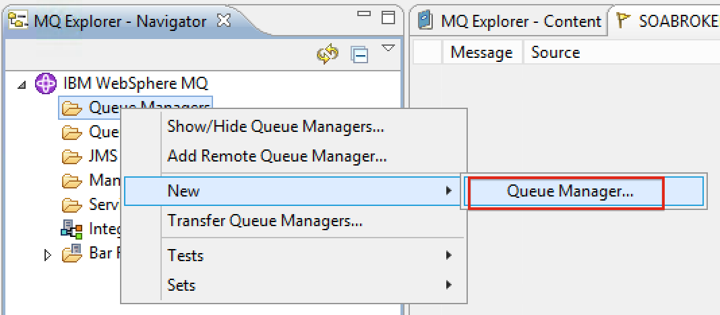

In the Create Queue Manager, enter a name for *Queue manager name* and click *Finish*.

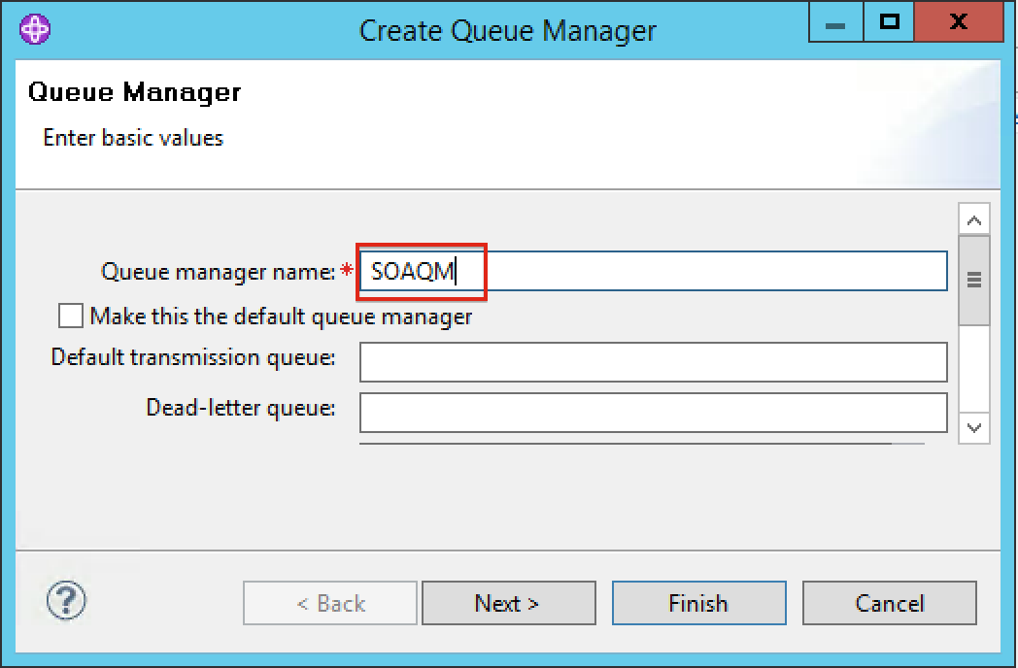

Note that the new Queue Manager has been created and is displayed under the Queue Managers folder.

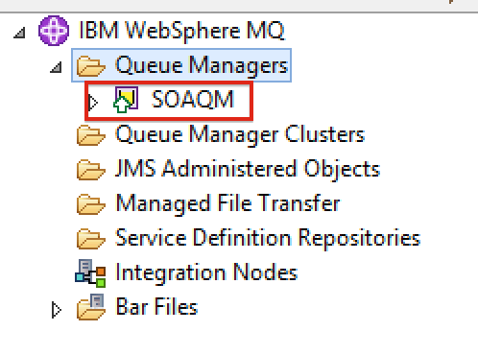

## Creating a Manager Broker

1. In the Integration Toolkit IDE, within the *Integration Nodes* view, right-click on *Integration Nodes*, select *New* and *Local Integration Node*.

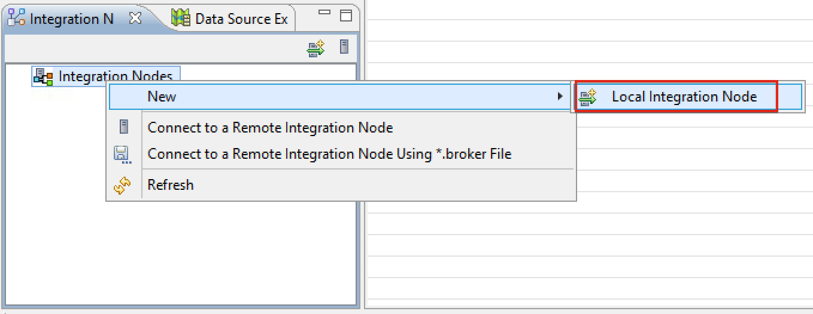

1. In the *New Local Integration Node* wizard, enter a name for *New broker name* and *Queue manager name* and click *Finish*.

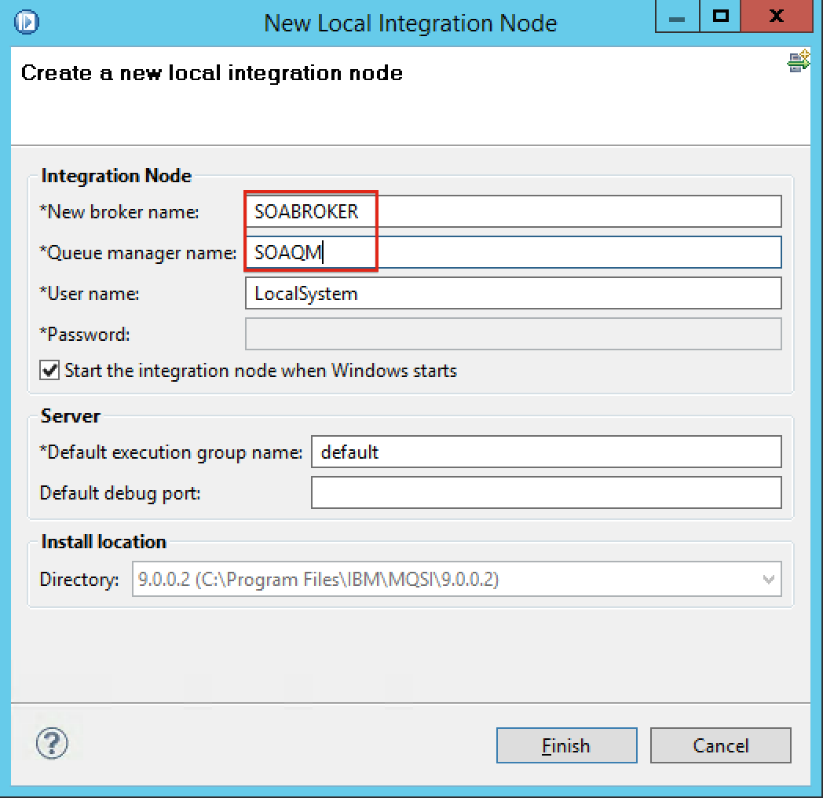

1. Note that the Queue Manager and Message Broker are displayed.

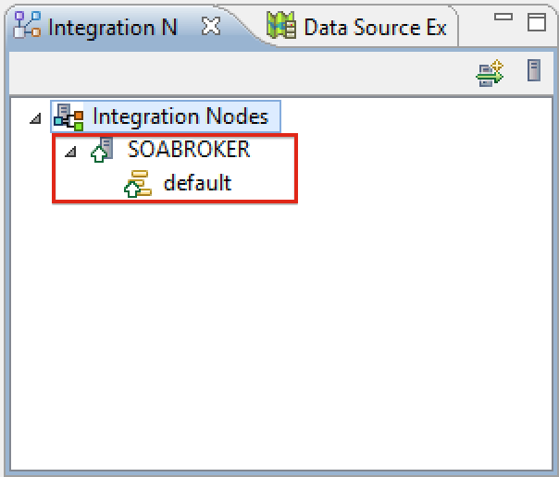

## Deploying a Flow in IIB

1. Right-click on the Flow and click *Deploy…*

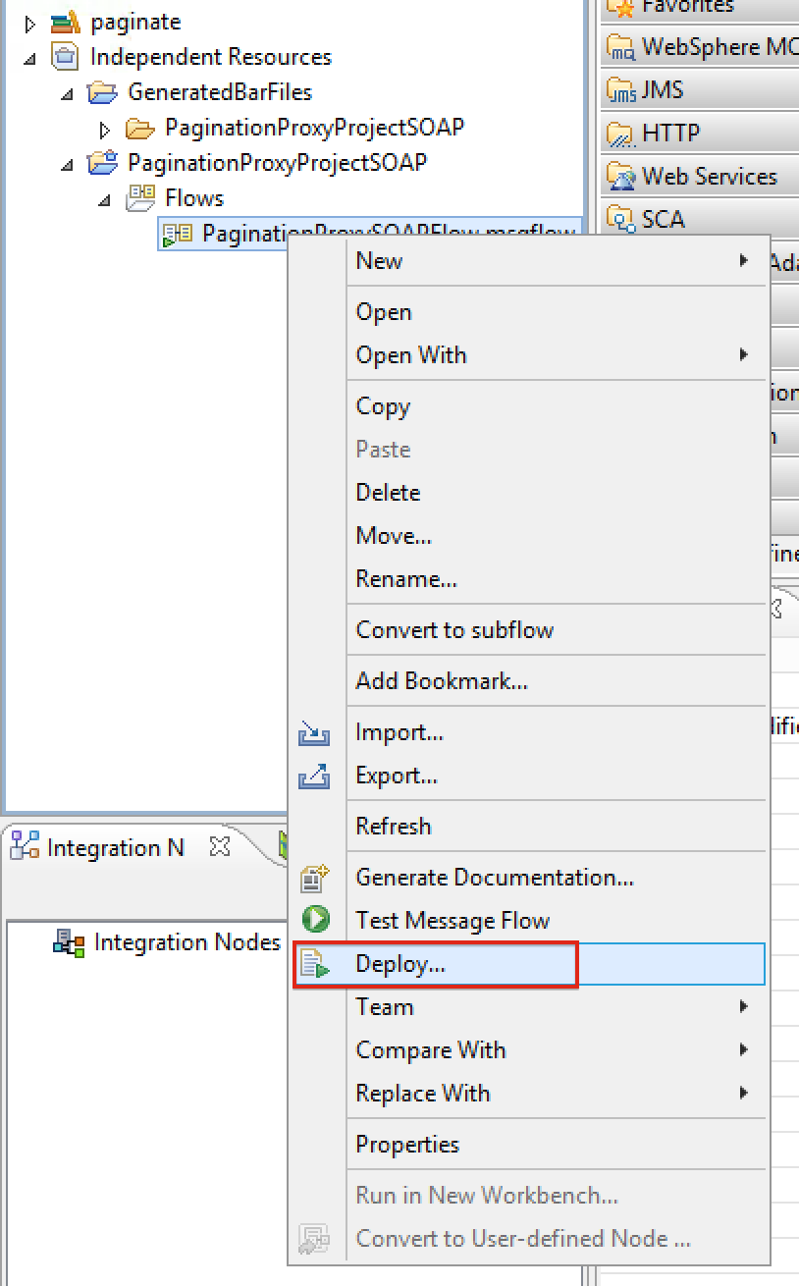

1. In the *Deploy* wizard, select the target integration server and click *Finish*.

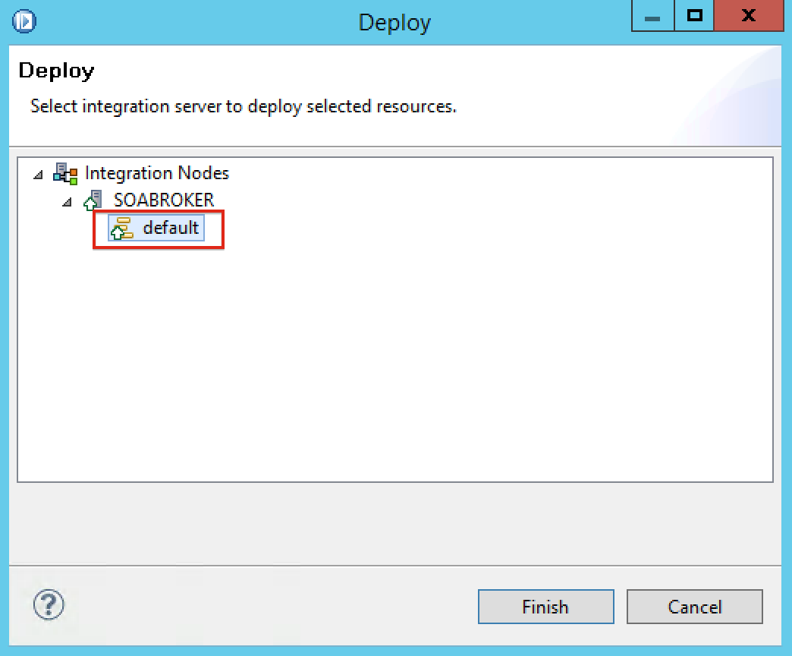

1. Note that the flow is deployed on the integration server

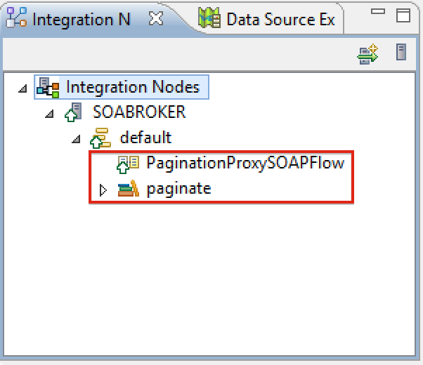

# HTTP Access Control in the USPS SOA Environment

## Introduction

The SOA Mobile team has installed and configured the Use Case API web service in the USPS SOA environment using the following architecture showing representative data flows:

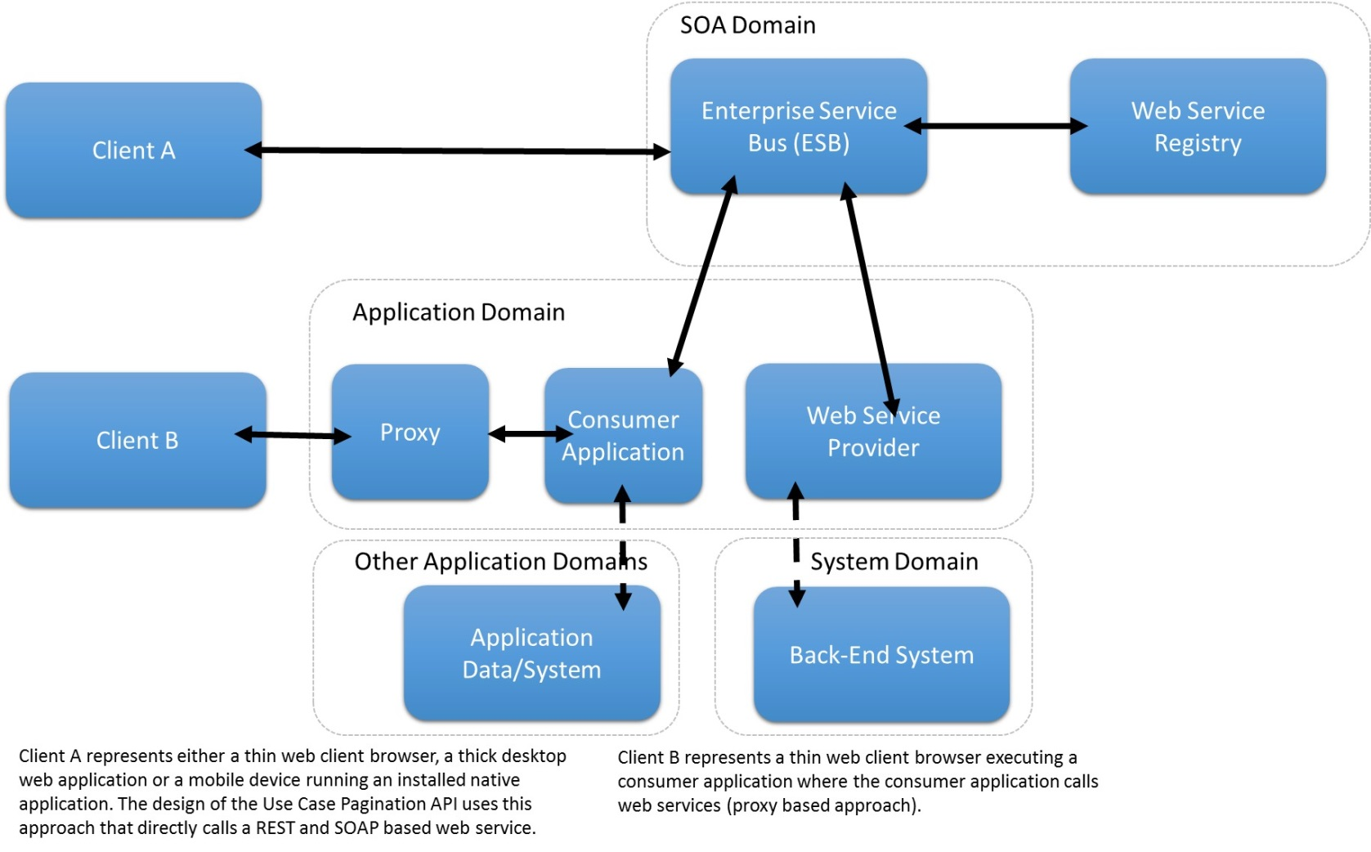

**2**

**1**

Figure - Use Case API Architecture

During testing, an HTTP access control issue has been discovered that occurs when a browser makes a web service call to a web service provider that is hosted in a different domain. In the above figure, when “Client A” (that represents the browser client), calls the web service directly through the ESB, an access control is violated. The access control built in and provided by most browsers is known as “Same-Origin Policy” (SOP). The SOP prevents HTTP requests accessing resources in different domain to prevent malicious attacks such as cross site scripting. Since the web service is not in the same origin or where it was called from, the SOP detects a violation.

For other cases where the client is not a browser and is not making a web service call that crosses domains, i.e. “Client B”, this security issue will not occur.

The SOA-Mobile team has addressed and resolved this issue and this paper describes the problem and provides some background and understanding of the specific solutions SOA-Mobile team has implemented.

## Problem

### Same-Origin Policy (SOP)

As previously mentioned, most modern browsers (IE, Firefox, Chrome, etc.), contain an HTTP access control feature called “Same Origin Policy”. This feature allows scripts running inside web pages to access other resources as long they are located in the same origin or domain. When a web page or script breaks this policy, through an algorithm that determines the ”origin”, the browser prevents the request from going through. (See Appendix A for examples about this policy.)

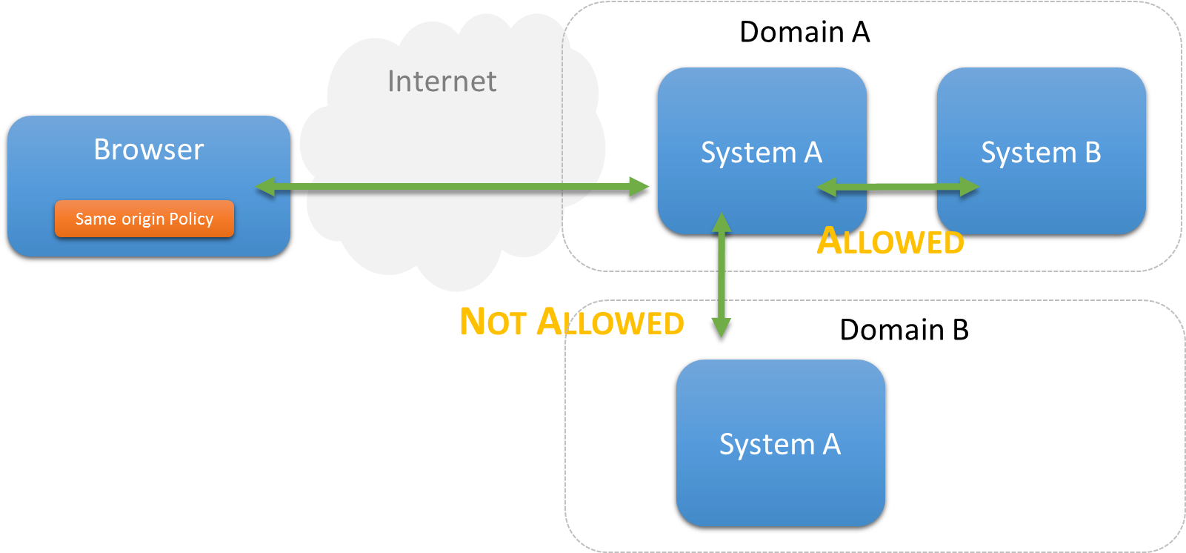

Figure - Access Control Issues

## Common Solutions

Common solutions or approaches to get around this problem include:

* CORS (Cross-Origin Resource Sharing)
* Proxy Server
* JSONP
* Others

For the scope of this paper, the only solutions that will be examined will be CORS and Proxy Server.

### CORS

Background

Cross Origin Resource Sharing (CORS) is a mechanism and a standard built in most modern browsers that address SOP issues, essentially the opposite of what SOP does. It is a mechanism that allows a web page to access other resources outside of the domain from where the resource originated from.

CORS works by setting the HTTP header fields or values sent by the browser when it makes a request to a web resource. (HTTP header fields are values passed to a web server and can be set programmatically).

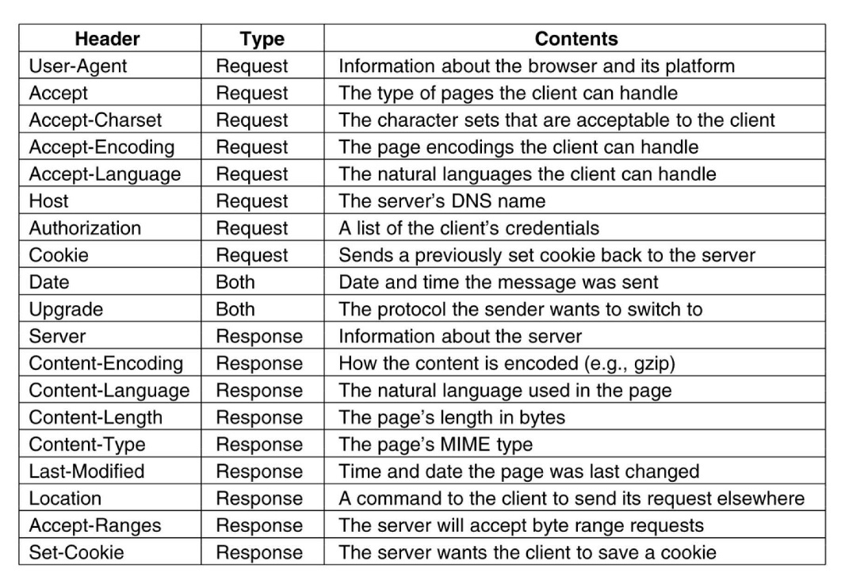

Figure : Common HTTP Header Fields sent in a HTTP Request or Response

There are generally two types of requests, where CORS is used to detect cross domain access:

* “Simple” HTTP Request – Typically no cross domain requests and CORS mechanism not needed.
* “Not-so-simple” HTTP Request – CORS mechanism needed to allow cross-domain requests

### “Simple” HTTP Request

A “simple” HTTP request is where the header fields are set to the following parameters:

1. HTTP Method field matches (case-sensitive)
   1. HEAD
   2. GET
   3. POST
2. HTTP Header field matches
   1. Accept – Can have any value
   2. Accept-Language – Can have any value
   3. Content-Language – Can have any value
   4. Last-Event-ID
   5. Content-Type – Has to be one of the following values
      1. application/x-www-form-urlencoded
      2. multipart/form-data
      3. text/plain

If all of the above is satisfied CORS is not needed.

### “Not-so-simple” HTTP Request

A “not-so-simple” HTTP request is if the request satisfies anything other than a “simple” HTTP request. If that is the case, the CORS mechanism is enabled.

In a real world situation, the “Accept” and “Content-Type” HTTP headers will usually be the following values for the following situations:

1. REST
   1. Content-Type: application/json
   2. Accept: application/json
2. SOAP
   1. Content-Type: text/xml
   2. Accept: application/xml, text/xml

Thus, CORS is a common problem with a Browser-to-System request, since most requests are “Not-so-simple” requests (SOAP, REST, etc.).

### Details of CORS request

When a request occurs where CORS is triggered, due to a “not-so-simple” request, the following flow occurs:

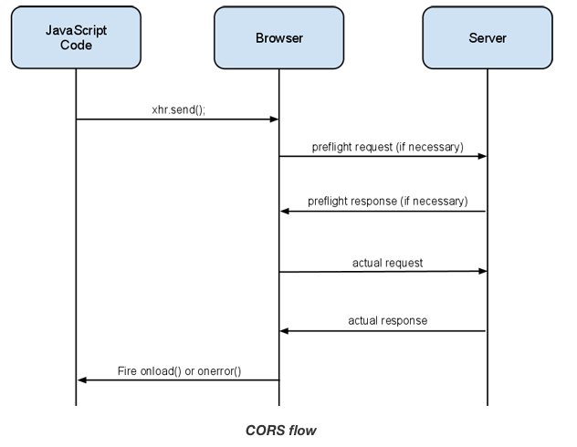

Figure : CORS flow

In a typical request and response transaction between a browser and a server, there are actually 2 communications that occur consecutively: 1) first what is known as the “preflight” request and then a server response, and then 2) the actual request and final server response.

1. Preflight request
   1. Happens before the actual request, the preflight request is where the CORS magic happens. This request essentially will check with the Server to make sure it is allowed to talk with the Browser.
   2. HTTP Method
      1. OPTIONS
   3. HTTP Headers
      1. Access-Control-Request-Headers
         1. Any headers that are not in a “simple” request (e.g. custom headers “myNewHeader”)
      2. Access-Control-Request-Method
         1. The HTTP method that the “actual” request (below) will make (e.g. GET, POST, etc.)
   4. This usually does not happen every request. The browsers usually cache the response from the preflight request. So if the browser remains open, or does not go over a certain set timeout, the preflight request only happens once.
2. Preflight response
   1. HTTP Header
      1. Access-Control-Allow-Origin
         1. Can be “*” to allow any origin, or at least has to match the preflight request’s HTTP “Origin” header’s value.
      2. Access-Control-Allow-Methods
         1. Comma separated values, and has to match the same value as in the preflight request’s HTTP “Access-Control-Request-Method” header’s value.
      3. Access-Control-Allow-Headers
         1. Comma separated values, and has to match the same values as in the preflight request’s HTTP “Access-Control-Request-Headers” header’s values.
      4. Access-Control-Max-Age (optional)
         1. Integer in seconds for how long the Browser should cache the preflight response values.
3. Actual request
   1. The actual request (GET, POST, etc.).
   2. Will have the appropriate HTTP headers set.

### Summary

* A CORS request only happens in a Browser-to-System request, since the Same-Origin Policy is built into all modern Browsers.
* A “simple” request will not result in a CORS request, but a “not-so-simple” request will result in a CORS request.
* A CORS request will have a preflight request, querying the server to request cross-domain access to it.

### Proxy Server

Please familiarize with CORS before proceeding with this section.

Due to the Same-Origin Policy, the following logic happens for an HTTP request:

* Is the request originating from a browser? Y/N
  1. Yes – Create a preflight request for CORS
  2. No – It’s a System-to-System, no preflight request for CORS

Thus, to get around the Same-Origin Policy, using a proxy server to handle the request (System-to-System) will not create a preflight request for CORS.

## Implemented Solutions

The following solutions have been implemented and tested in the USPS SOA environment.

### Server CORS Filter

The first solution is to implement a Java process in the server that filters all HTTP requests and appends the following HTTP headers in the response.

* Access-Control-Allow-Origin
  + Example: *
* Access-Control-Allow-Methods
  + Example: POST, GET, OPTIONS, DELETE, PUT
* Access-Control-Allow-Headers
  + Example: uspsConsumerID, uspsContextID, Accept, SOAPaction, Content-Type
* Access-Control-Max-Age (optional)
  + Example: 3600

Sequence diagram below shows the flow that was deployed in the USPS SOA environment.

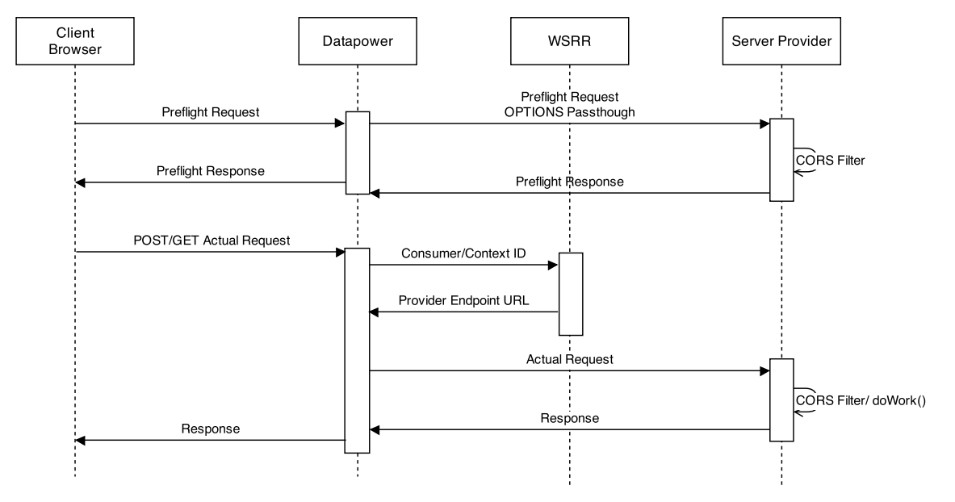

Figure : Server CORS Filter Solution

### Pros

1. Adheres to a web application security model
2. Each provider can have their own CORS security mechanism, thus scalable from a provider’s sense.

### Cons

1. Filter always gets triggered, even with a non-preflight request
2. Provider has to implement CORS security mechanism

## DataPower CORS solution

The second solution is a configuration made in the DataPower appliance that handles HTTP requests and responses by looking at the OPTIONS field values during the preflight request. DataPower will respond to all OPTIONS requests with the following response headers.

* Access-Control-Allow-Origin
  + Example: *
* Access-Control-Allow-Methods
  + Example: POST, GET, OPTIONS, DELETE, PUT
* Access-Control-Allow-Headers
  + Example: uspsConsumerID, uspsContextID, Accept, SOAPaction, Content-Type
* Access-Control-Max-Age (optional)
  + Example: 3600

Sequence diagram below shows the flow that was deployed in the USPS SOA environment.

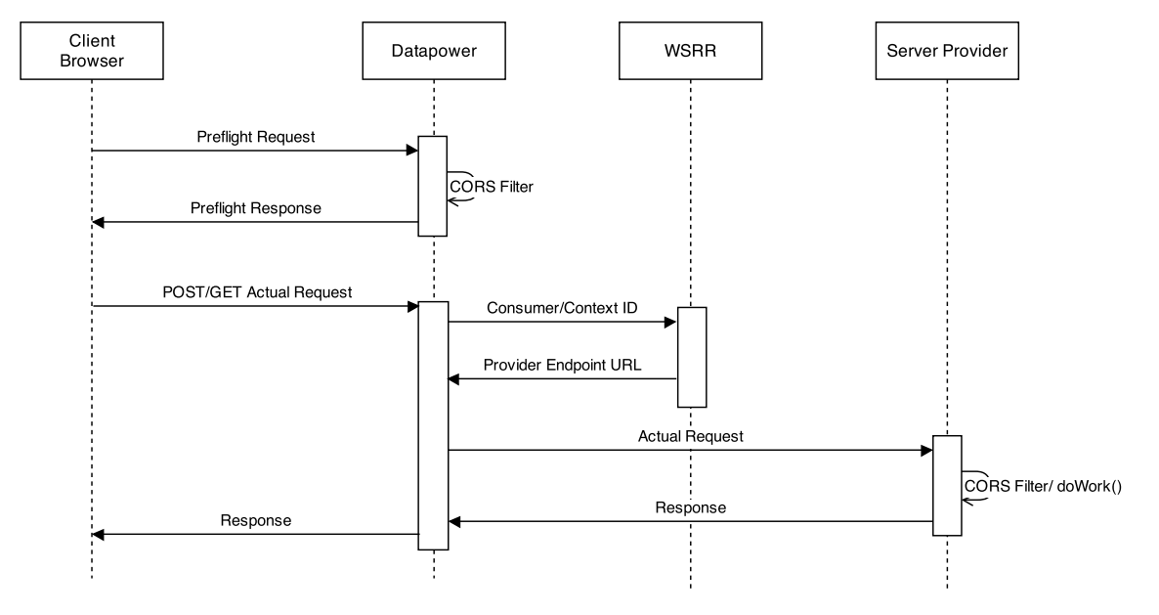

Figure : DataPower CORS Filter Solution

### Pros

1. DataPower gateway will take control of the CORS issue, thus anything behind DataPower (IIB, WAS, etc.) do not have to worry about it.
2. This solution will save CPU cycles from the “Server CORS Filter” solution, since not every HTTP request will be hit by the filter in DataPower.

### Cons

1. Does not adhere to a web application security model.
2. OPTIONS request is non-existent to the rest of the system, since DataPower never passes it through.
3. Teams have to coordinate with DataPower to get custom CORS to work with their servers.

## Proxy Server

The third solution is to use a Proxy Server. This is a different architectural approach where the browser request is forwarded to a proxy which then makes the actual request hence avoids the SOP violation. The main ideas behind this approach are:

* The proxy server should be hosted in the consumer (web page source files) server. Thus, when the browser does a request, it will go to the same domain (no cross domain occurs), which adheres to the Same-Origin Policy.
* The browser will hand over the request to the proxy server, thus the proxy server is doing a System-to-System request and not a Browser-to-System request.

Sequence diagram below shows the flow that was deployed in the USPS SOA environment.

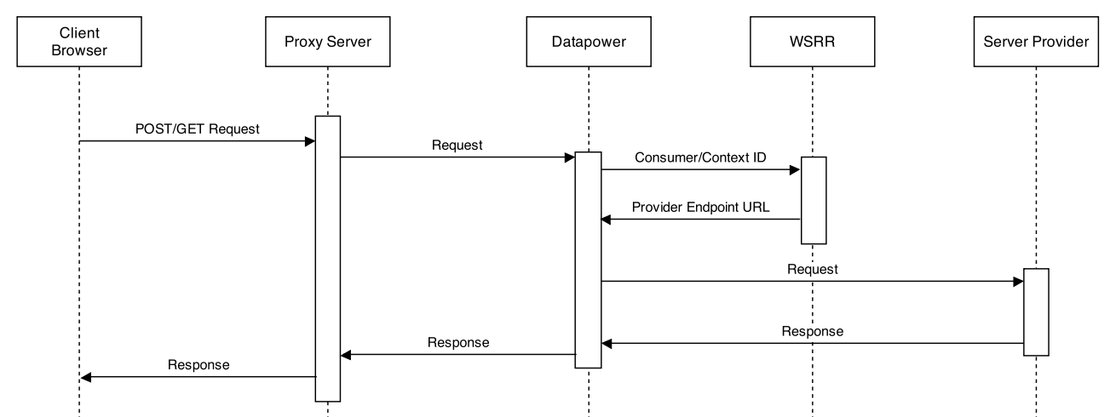

Figure : Proxy Server Solution

### Pros

1. CORS will not be an issue, thus DataPower or the Server Providers do not need to waste CPU cycles for a solution mechanism.
2. System-to-System requests can have more control than Browser-to-System requests.

### Cons

1. An extra hop is in the network, the proxy server.
2. The proxy server is a bottle-neck, need to consider load-balancing solutions for the proxy server.
3. Need to invest in commercial proxy servers for better performance in high traffic real-world deployments.

## Appendix A – Same-origin policy examples

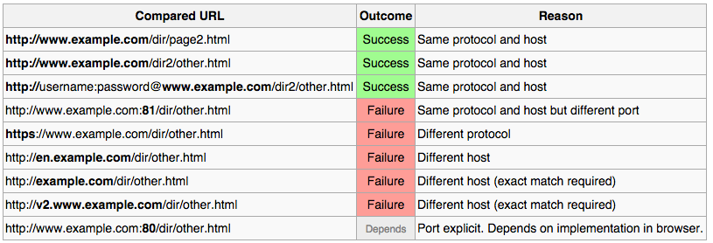

# As-Is and To-Be Web Services

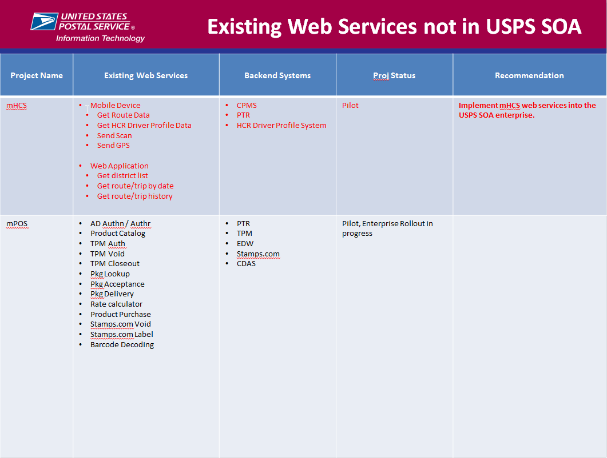

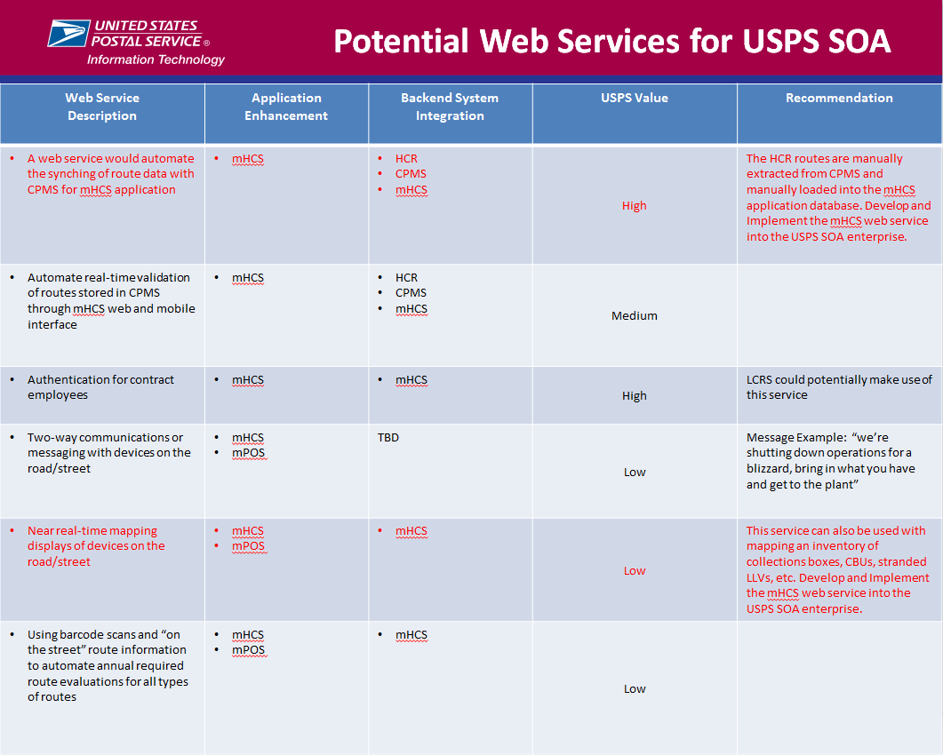

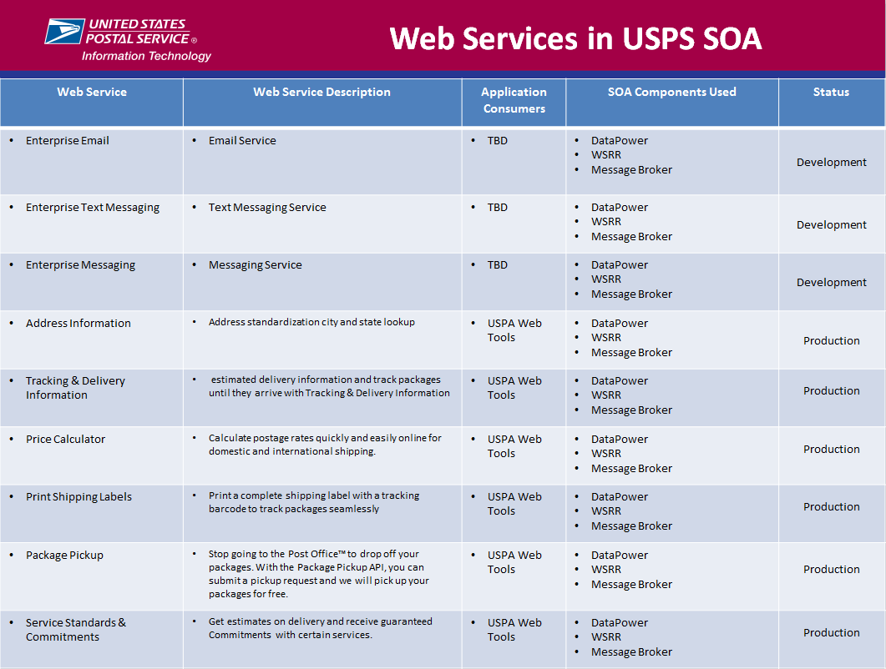

# USPS SOA-Mobile Reference Architecture

## Objective

* Describe the USPS Services Oriented Architecture and the specific technologies used for USPS SOA
* Show a Reference Architecture for SOA that describes how USPS SOA is used in the context of USPS Customers, Systems, USPS Organizations and Mobile technologies
* Show high level data flows that may serve as an architectural pattern to better understand how web services are implemented in USPS SOA
* Identify common decision points for architects and developers

## USPS Services Oriented Architecture Technology

Based on IBM technology stack

1. IBM DataPower XI52
2. IBM Web Service Registry and Repository (WSRR) v8.5
3. 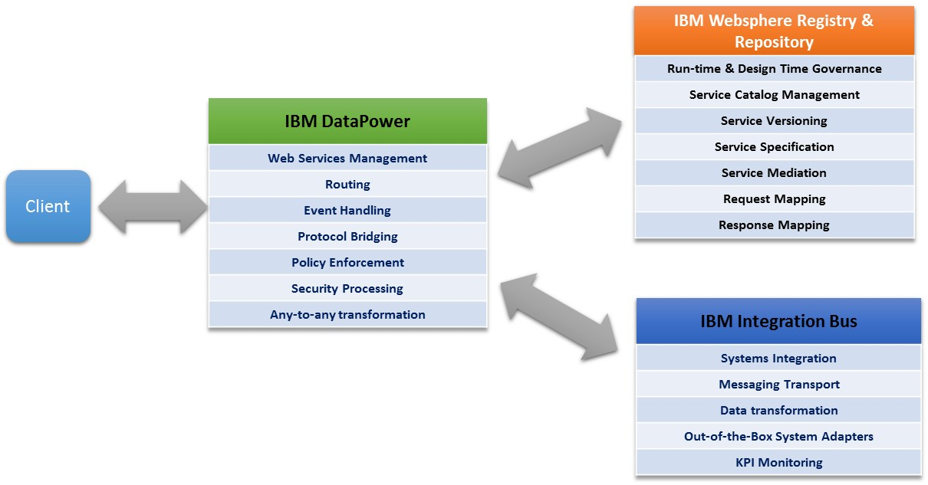IBM Integration Bus (IIB) v9.0

## Context of SOA within the Mobile Computing Framework Architecture

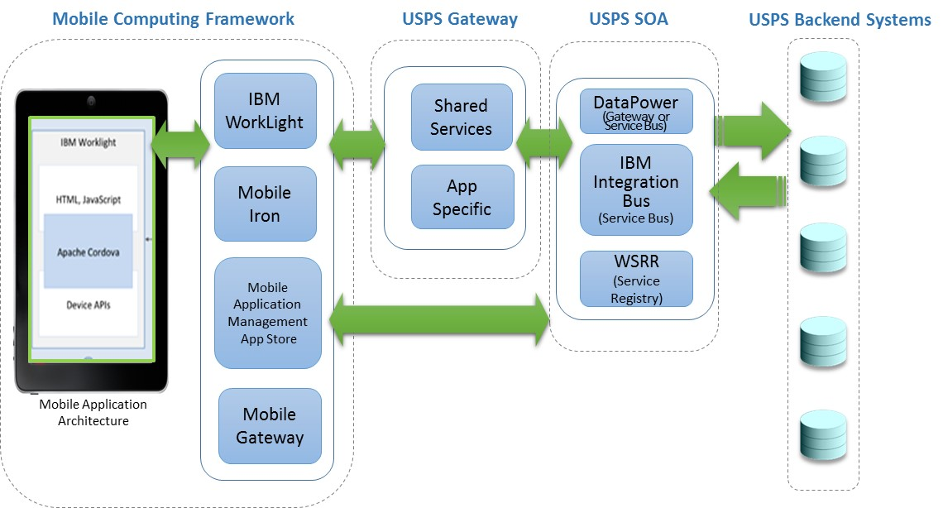

## Mobile SOA Reference Architecture

### What is a Reference Architecture?

* Provides solution and enterprise architects a standardized blueprint from which to architect solutions

### Use Cases

* Reference architectures can be used to set the context for an architecture, to provide a common foundation to map SOA components and to articulate a set of building blocks for solutions.
* Reference architectures can be used by architects in a variety of scenarios which include jump starting IT projects that are adopting an SOA, helping system integrators that are providing services in the construction of an SOA, and helping other IT organizations that are building other SOA specifications and standards.

### Objectives:

* Provides a reference framework for registering SOAP and REST based web services
* Provides an enterprise view of business and system components
* Shows different architectural layers of USPS systems relative to SOA
* Shows known business capabilities aligning with technical capabilities
* Shows the SOA architecture within the context of Mobile Computing framework architecture

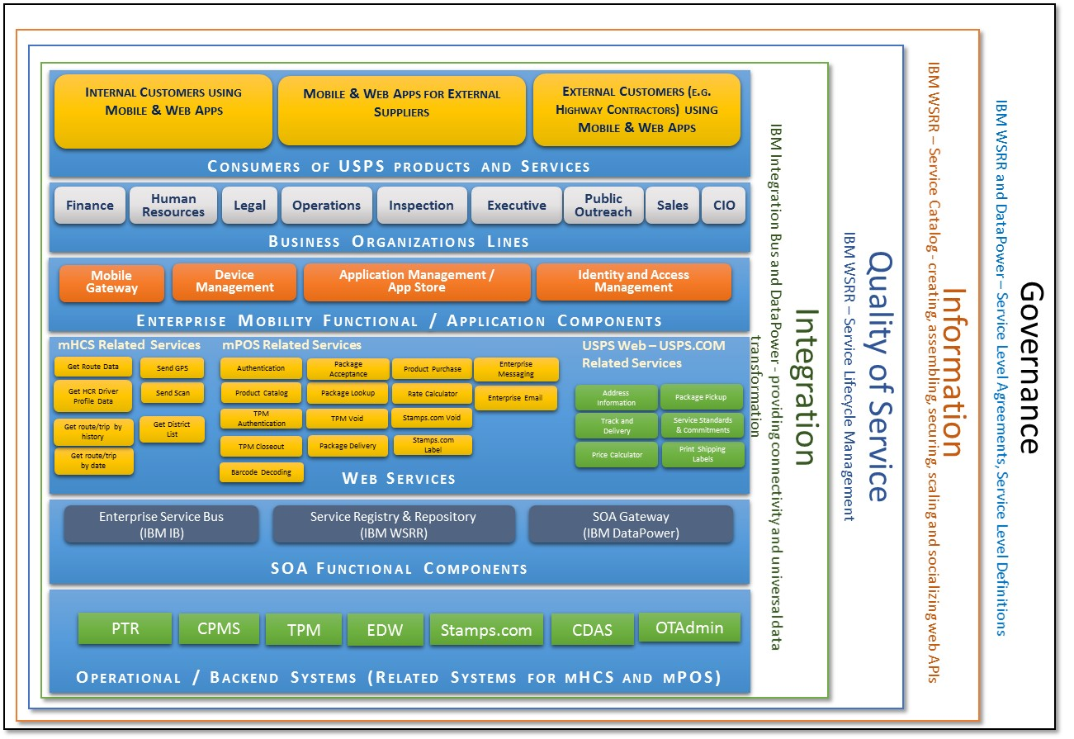

### Description of Layers

The layers that are defined in the SOA Reference Architecture provide a set of capabilities that are then realized through the use of the architectural building blocks. A brief description of these layers is provided below:

* **Operational Systems Layer** – captures the new and existing organization infrastructure and is needed to support the SOA solution at design, deploy and run time.
* **Service Component Layer** – contains software components, each of which provide the implementation or “realization” for a service, or operation on a service. The layer also contains the functional and technical components that facilitate a Service Component to realize one or more services.
* **Services Layer** – consists of all the services defined within the SOA. The service layer can be thought of as containing the service descriptions for business capabilities, services and IT manifestation used/created during design time as well as runtime service contracts and descriptions that used at runtime.
* **Mobile Business Process Layer** – covers the process representation, composition methods and building blocks for aggregating loosely coupled services from mobile enabled applications as a sequencing process aligned with business goals.
* **Mobile Component Layer** – contains software components to support mobile applications, each of which provide the implementation or “realization” for a service, or operation on a service.
* **Consumer Layer** – where consumers interact with the SOA. It enables a SOA solution to support a client-independent, channel agnostic set of functionality, which is separately consumed and rendered through one or more channels (client platforms and devices).
* **Integration Layer** – enables and provides the capability to mediate, which includes transformation, routing and protocol conversion to transport service requests from the service requester to the correct service provider.
* **Quality of Service Layer** – supports non functional requirement (NFR) related issues as a primary feature/concern of SOA and provides a focal point for dealing with them in any given solution.
* **Information Architecture Layer** – is responsible for manifesting a unified representation of the information aspect of an organization as provided by its IT services, applications, and systems enabling business needs and processes and aligned with the business vocabulary – glossary and terms. This enables the SOA to support data consistency, and consistency in data quality.
* **Governance Layer** – contains the registries, repositories, and other capabilities required to support the governance of your SOA within the SOA ecosystem and is adapted to match and support the target SOA goals of the organization.

## USPS SOA Architecture Pattern

Client A represents either a thin web client browser, a thick desktop web application or a mobile device running an installed native application. The design of the Use Case Pagination API uses this approach that directly calls a REST and SOAP based web service

Client B represents a thin web client browser executing a consumer application where the consumer application calls web services (proxy based approach).

## DataPower as ESB Dataflow – Scenario A

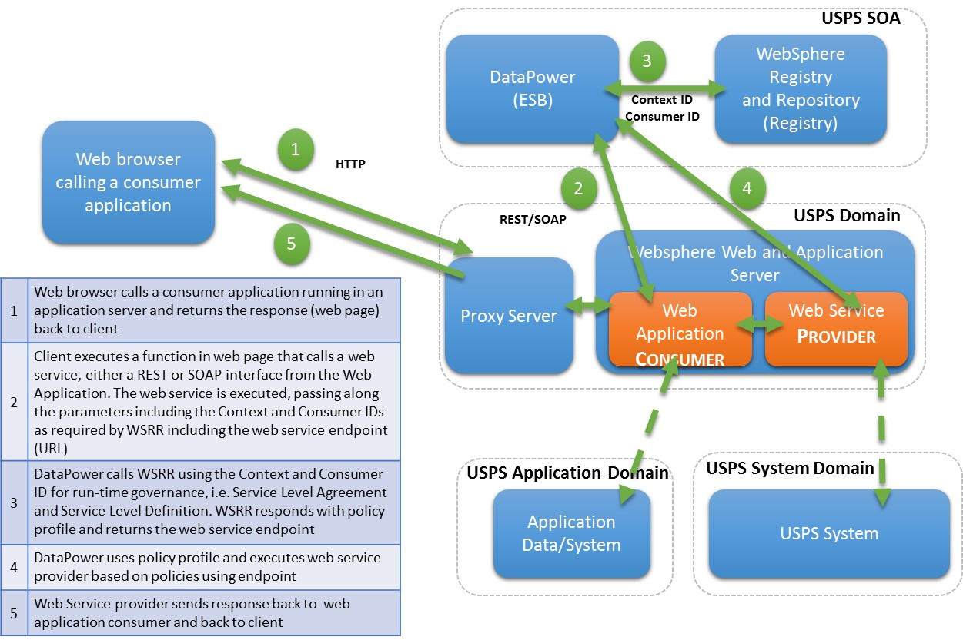

## DataPower as ESB Dataflow – Scenario B

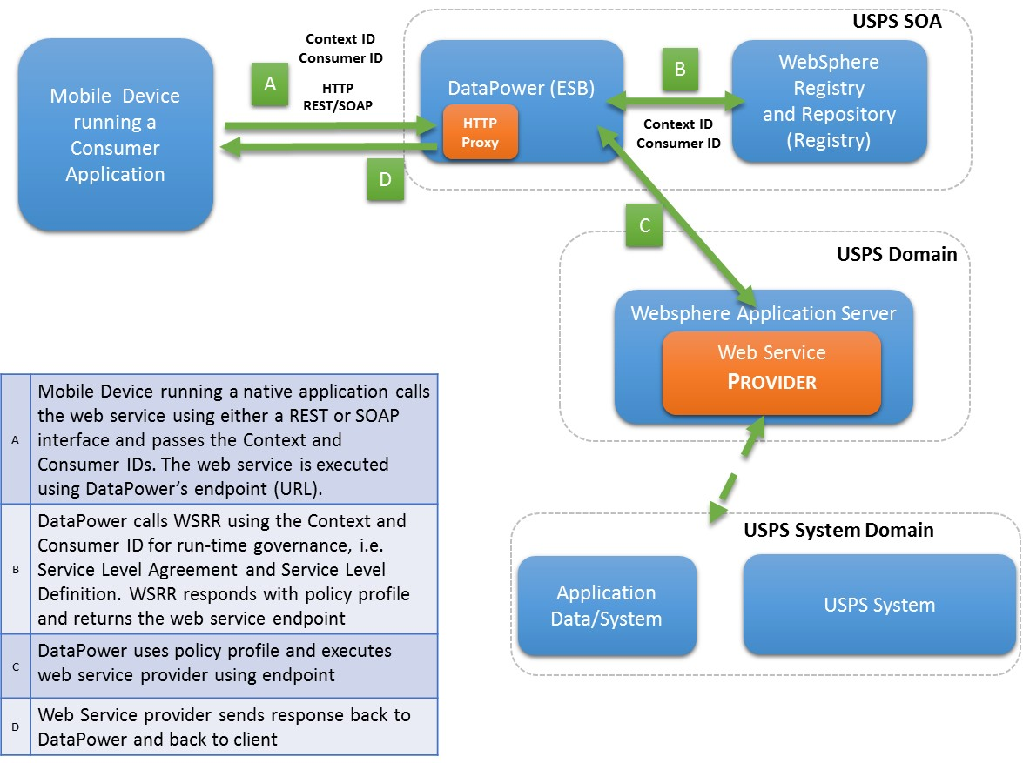

## IBM Integration Bus (IIB) as ESB Dataflow – Scenario A

## IBM Integration Bus (IIB) as ESB dataflow – Scenario B

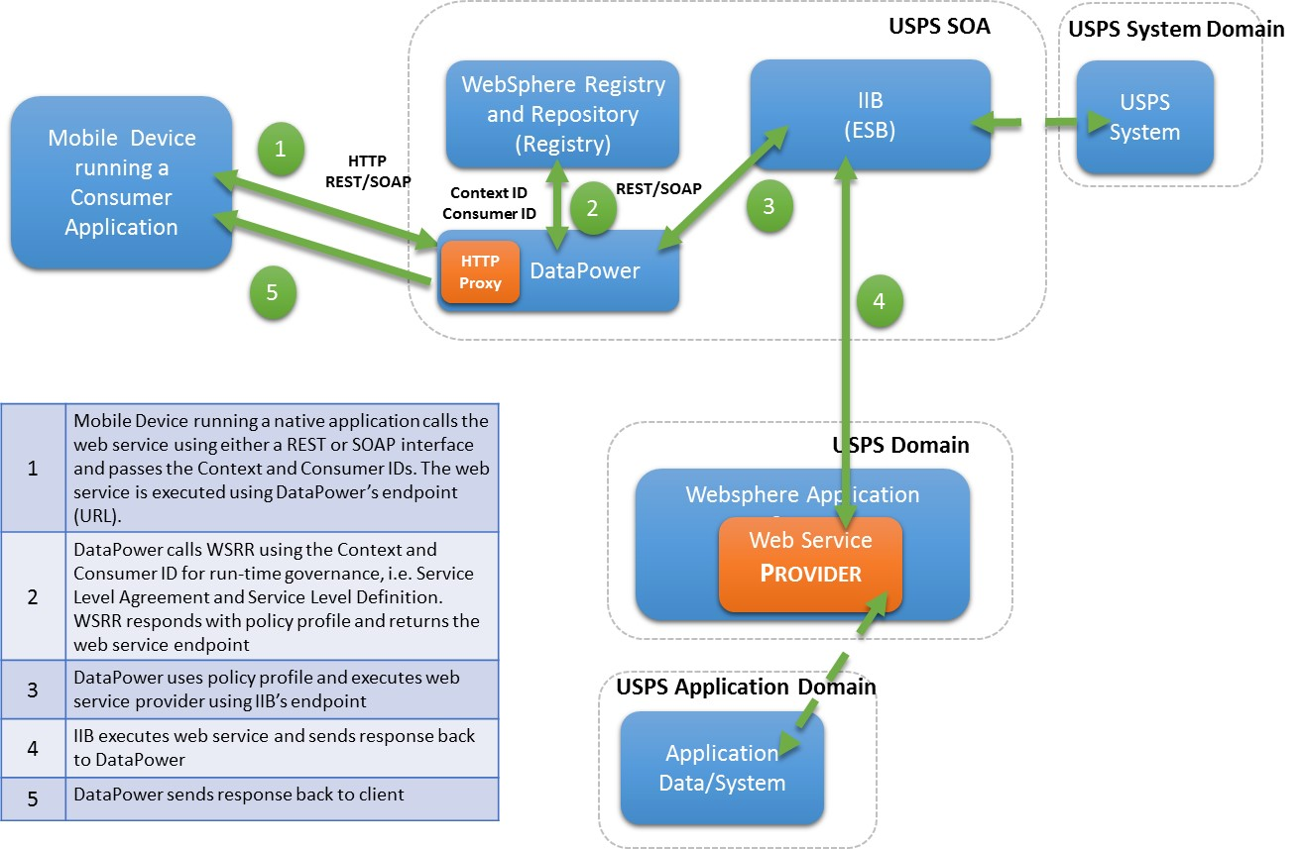

## Decision Points

### DataPower

|  |  |  |
| --- | --- | --- |
| Audience | Decision | Guidance |
| Consumer | I'm deploying a web application. Do I need DataPower? | While DataPower can front web applications and provide some security, USPS does not typically front web applications with DataPower. |
| Provider | I'm deploying a web service. Do I need DataPower? | The recommended USPS configuration for reusable web services and APIs is to use DataPower to provide the following:  Security - DOS attacks - XML threat protection - non-XML threat protection, e.g. Cross Site Scripting and SQL Injection - Message-level XML Security at wire speed (as needed)  XML/SOAP validation Intelligent policy-based traffic routing Support for WSRR integration - Dynamic endpoint routing - SLA enforcement  Support for monitoring (ITCAM) |

### DataPower and WSRR

|  |  |  |
| --- | --- | --- |
| Audience | Decision | Guidance |
| Provider | I'm deploying a web service. Do I need to configure DataPower to route to a dynamic endpoint? | This is a recommended configuration following the location transparency pattern and will allow deployment flexibility for the service provider. Service consumers will only see the DataPower entry point and any change to the location of the service provider's backend endpoint will be transparent to consumers. |

### DataPower and IIB

|  |  |  |
| --- | --- | --- |
| Audience | Decision | Guidance |
| Provider | I need ESB functionality. Should I use DataPower or IIB? | DataPower provides much of the baseline functionality that is provided by ESBs. This functionality includes: - service virtualization (dynamic endpoint routing) - protocol bridging - data format transformations  The following are notable differentiators: - DataPower appliance will be faster solution, based on appliance. - DataPower requires less maintenance overhead, from operational perspective. - DataPower is intended for short-lived (ms) transactions. - IIB has much larger support for protocols and data formats and may be the only option. - IIB supports more robust multi-step data flows and orchestrations.  In general, prefer DataPower for performance and maintainability unless the more robust functionality of IIB is required. |

### REST, SOAP, JSON, and XML

|  |  |  |  |
| --- | --- | --- | --- |
| Audience | Category | Decision | Guidance |
| Provider | REST, SOAP | I'm developing a web service. Are there any architectural implications I should be aware of with respect to developing a REST or SOAP service? | REST relies on the transport layer, e.g. HTTP, to transfer metadata and method. Conversely metadata for SOAP messages are within the SOAP header. Thus the SOAP messages are autonomous and decoupled from the transport.   SOAP is preferred for: - asynchonous messaging with support of WS-ReliableMessaging, e.g. utilizing MQ - when a formal contract is required - there are requirements for functionality provided through the robust WS-* extensions (security, trust, transactions, coordination, etc.). Note that these are commonly addressed as intermediaries deployed in an ESB. - stateful operations  REST is preferred for: - lower bandwidth - stateless operations - support for caching due to stateless nature |
| Provider | REST, JSON, XML | I'm developing a REST web service. Are there any implications I should be aware of with respect to supporting JSON, XML, or BOTH? | All of these formats are supported by the architecture. Whichever option is chosen must be communicated to Operations so that DataPower can be configured to allow the desired format(s) to validated and pass through. |

### Others

|  |  |  |  |
| --- | --- | --- | --- |
| Audience | Category | Decision | Guidance |
| Provider | IIB, WAS | What factors contribute to the decision of what custom logic should be deployed in an ESB versus an application server? | Good candidates for deployment in the application server: - business logic and logic that tends to change  Good candidates for deployment in the ESB - policies that tend to be static and which cannot be deployed using the preferred architecture: storing policies in WSRR and enforcing them in DataPower. - cross-cutting logic - intermediaries for processing SOAP messages |
| Provider, Consumer |  | From an archtitectural perspective, what is the implication of exposing my web service directly to mobile and web (AJAX) consumers versus requiring consumers to proxy requests via a server-side "gateway" component? | Consumers Direct access to web services: - Simple architecture not relying on development/maintenance of serverside component - Consumers must develop workaround for Same Origin Policy (SOP) in browsers, e.g. CORS Server-side "gateway" proxy: - Ability for consumers to implement intermediaries on all traffic, e.g. audit requests  Providers Direct access to web services: - This is an acceptable approach if desired by consumers if there are minimal requirements for access control such as with internal consumers (ACE authenticated users originating requests within the firewall). - Providers must implement support for CORS. Server-side "gateway" proxy: - When consumer system trust is required, it is easier to manage a certificate of a single consuming system versus many mobile and web clients. - There are multiple approaches to handle authentication if required. One approach is to accept a user ID from a proxy "gateway" based on the trust of that system. More robust solutions, such as an Security Token Service (STS), will support authentication users using the approach of direct consumer access to web service. |
| Consumer | SOP | We are accessing web services directly from our web and/or mobile consumers but the browser is blocking our requests due to enforcement of Same Origin Policy (SOP). How can we get around this? | Cross-Origin Resource Sharing (CORS) - Modern browsers support CORS as a workaround to SOP to serve content across domain boundaries. Service Providers must implement support for CORS.  Note that for development cycles, it is possible to disable enforcement of SOP in browsers. |

# Sprint Backlog

Below are the tasks for the development and deployment of the Use Case web service API. Tasks include design, development, testing and deployment of the web service in both Agilex and USPS SOA development environments.

|  |  |  |  |  |  |  |
| --- | --- | --- | --- | --- | --- | --- |
| User Story | Task | ID | Owner | Status | Est. Hours | Sprint |
| VersionOne Enablement | Request access for team members | TK-83071 | Jody Sevidal | Completed | 1.00 | Sprint 1 |
| VersionOne Enablement | assign team members to SOA VersionOne project | TK-83073 | Jody Sevidal | Completed | 1.00 | Sprint 1 |
| VersionOne Enablement | Train team on VersionOne usage | TK-83074 |  | Completed | 2.00 | Sprint 1 |
| SOA Web Access Implementation | Install Websphere Server | TK-83840 | Yue Chao Qin | Completed | 4.00 | Sprint 2 |
| SOA Web Access Implementation | Install/setup development environment | TK-83842 | Yue Chao Qin | Completed | 8.00 | Sprint 2 |
| SOA Web Access Implementation | Design Framework for REST Service | TK-83843 | Yue Chao Qin | Completed | 2.00 | Sprint 2 |
| SOA Web Access Implementation | Development and Test REST Service | TK-83848 | Yue Chao Qin | Completed | 12.00 | Sprint 2 |
| SOA Web Access Implementation | Functional testing and verification | TK-83856 | Yue Chao Qin | Completed | 6.00 | Sprint 2 |
| SOA Web Access Implementation | Deploy and validate REST Service for Demo | TK-83857 | Yue Chao Qin | Completed | 6.00 | Sprint 2 |
| SOA Web Access Implementation | Acquire virtual machine for development | TK-83925 | Jody Sevidal | Completed | 8.00 | Sprint 2 |
| SOA Web Access Implementation | Set-up and configure virtual instance | TK-83926 | Jody Sevidal | Completed | 6.00 | Sprint 2 |
| SOA Web Access Implementation | Install WAS in development environment | TK-83927 | Steven Dickson | Completed | 3.00 | Sprint 2 |
| SOA Web Access Implementation | Configuration & Troubleshoot install/connection/security issues | TK-83929 | Steven Dickson | Completed | 4.00 | Sprint 2 |
| SOA Web Access Implementation | Capture version numbers of SOA products install at USPS | TK-83934 | Steven Dickson | Completed | 4.00 | Sprint 2 |
| SOA Web Access Implementation | Request access to SOA systems/products | TK-83940 | Farah Bandukwala,Steven Dickson,Jody Sevidal | Completed | 8.00 | Sprint 2 |
| SOA Web Access Implementation | Install WSRR on development server | TK-83950 | Michael Kasun,Steven Dickson | Completed | 16.00 | Sprint 2 |
| SOA Web Access Implementation | Install WMB on development server | TK-83951 | Steven Dickson | Completed | 16.00 | Sprint 2 |
| SOA Web Access Implementation | Install API management tool | TK-83952 | Steven Dickson | Completed | 16.00 | Sprint 2 |
| SOA Web Access Implementation | Demo Progress as needed | TK-83953 | Farah Bandukwala,Steven Dickson,Yue Chao Qin,Jody Sevidal | Completed | 8.00 | Sprint 2 |
| Web Client Access | Design web client | TK-83889 | Yue Chao Qin | Completed | 4.00 | Sprint 2 |
| Web Client Access | Implement web client | TK-83890 | Yue Chao Qin | Completed | 6.00 | Sprint 2 |
| Web Client Access | Test web client | TK-83892 | Yue Chao Qin | Completed | 2.00 | Sprint 2 |
| AS-IS Web Services Catalog | Install a Web Service in WSRR on Agilex Dev instance | TK-86331 | Steven Dickson | Completed | 8.00 | Sprint 3 |
| AS-IS Web Services Catalog | Analyze and Configure WSRR to automatically discover and generate Web Service Catalog | TK-86332 | Steven Dickson | Completed | 8.00 | Sprint 3 |
| AS-IS Web Services Catalog | Configure Web Service in WSRR in Agilex Dev instance | TK-86437 | Steven Dickson | Completed | 8.00 | Sprint 3 |
| AS-IS Web Services Catalog | Document Steps for Creation of Web Service Catalog through WSRR | TK-86464 | Steven Dickson | Completed | 4.00 | Sprint 3 |
| SOA-Mobile Reference Architecture | Develop A SOA-Mobile Reference Architecture based on USPS SOA infrastructure IBM components | TK-86328 | Jody Sevidal | Completed | 8.00 | Sprint 3 |
| SOA-Mobile Reference Architecture | Vet and Review Reference Architecture with Client | TK-86329 | Jody Sevidal | Completed | 4.00 | Sprint 3 |
| SOA-Mobile Reference Architecture | Respond to client feedback | TK-86330 | Jody Sevidal | Completed | 4.00 | Sprint 3 |
| TO-BE Web Services Catalog | Document process and steps for adding and configuring a new web service | TK-86342 | Steven Dickson | Completed | 4.00 | Sprint 3 |
| TO-BE Web Services Catalog | Identify SLA, Monitoring and Security Governance aspects | TK-86343 | Steven Dickson | Completed | 8.00 | Sprint 3 |
| Web Service Installation at USPS infrastructure | Configure USPS DataPower on USPS SOA | TK-86333 | Yue Chao Qin | Completed | 8.00 | Sprint 3 |
| Web Service Installation at USPS infrastructure | Install DataPower VM on Agilex Dev instance | TK-86334 | Yue Chao Qin | Completed | 8.00 | Sprint 3 |
| Web Service Installation at USPS infrastructure | Analyze and Document DataPower and WAS integration | TK-86335 | Steven Dickson | Completed | 8.00 | Sprint 3 |
| Web Service Installation at USPS infrastructure | Work with ITSA architect to install and configure web service in ITSA environment | TK-86336 | Yue Chao Qin | Completed | 4.00 | Sprint 3 |
| Web Service Installation at USPS infrastructure | Assist in the Integration of DataPower, WSRR, WAS and Web Service in USPS environment | TK-86337 | Yue Chao Qin | Completed | 8.00 | Sprint 3 |
| Web Service Installation at USPS infrastructure | Test web service in USPS environment using DataPower and WAS | TK-86338 | Steven Dickson | Completed | 8.00 | Sprint 3 |
| Web Service Installation at USPS infrastructure | Install WSRR in Agilex Dev environment | TK-86432 | Yue Chao Qin | Completed | 8.00 | Sprint 3 |
| Web Service Installation at USPS infrastructure | Integrate and Test Web Service in Agilex Dev Environment using DataPower, WSRR and WAS | TK-86433 | Steven Dickson | Completed | 8.00 | Sprint 3 |
| Web Service Installation at USPS infrastructure | Configure DataPower in Agilex Dev instance | TK-86443 | Steven Dickson | Completed | 8.00 | Sprint 3 |
| Web Service Installation at USPS infrastructure | Configure WSRR in Agilex Dev Environment | TK-86458 | Steven Dickson | Completed | 8.00 | Sprint 3 |
| Complete the Draft for SOA Mobile Reference Architecture | Update the Reference Architecture Based on the Installation and Configuration Tasks | TK-89692 |  | Completed | 8.00 | Sprint 4 |
| Complete the Draft for SOA Mobile Reference Architecture | Develop Design Pattern for Web Services | TK-89693 |  | Completed | 4.00 | Sprint 4 |
| Complete the Draft for SOA Mobile Reference Architecture | Resolve Same Origin Policy Issue (SOP) | TK-90330 |  | Completed | 16.00 | Sprint 4 |
| Enhance Consumer App for Integration with WSRR | Research WSRR Configuration for consumer id | TK-89704 |  | Completed | 2.00 | Sprint 4 |
| Enhance Consumer App for Integration with WSRR | Collaborate with WB SOA team on how to Consumer id & Context ID in request payload | TK-89705 |  | Completed | 8.00 | Sprint 4 |
| Enhance Consumer App for Integration with WSRR | Update Consumer Application Code with consumer id feature | TK-89706 |  | Completed | 4.00 | Sprint 4 |
| Enhance Consumer App for Integration with WSRR | Test and deploy in Sandbox | TK-89708 |  | Completed | 8.00 | Sprint 4 |
| Install and Configure a Web Service in WSRR for REST Interface | Collaborate with USPS (WB) SOA Team to Install and Configuration Web Service in WSRR | TK-89680 | Yue Chao Qin | Completed | 16.00 | Sprint 5 |
| Install and Configure a Web Service in WSRR for REST Interface | Document the Installation and Configuration | TK-89682 | Steven Dickson | Completed | 8.00 | Sprint 5 |
| Install and Configure a Web Service in WSRR for REST Interface | Test web service in USPS SOA environment using DP and WSRR | TK-89683 |  | Completed | 16.00 | Sprint 5 |
| Install and Configure a Web Service in WSRR for REST Interface | Finalize the Installation and Configuration Document | TK-89684 | Steven Dickson | Completed | 8.00 | Sprint 5 |
| Create CM Plan | Develop CM plan using github | TK-92584 | Farah Bandukwala | Completed | 6.00 | Sprint 6 |
| Create CM Plan | Check-in and version the use case API development artifacts using CM plan | TK-92586 | Yue Chao Qin | Completed | 8.00 | Sprint 6 |
| Install and Configure a Web Service in DP & WSRR for SOAP Interface | Implement SOAP Web Service for Consumer Application | TK-92253 | Yue Chao Qin | Completed | 8.00 | Sprint 6 |
| Install and Configure a Web Service in DP & WSRR for SOAP Interface | Implement SOAP Web Service for Provider App | TK-92254 | Yue Chao Qin | Completed | 8.00 | Sprint 6 |
| Install and Configure a Web Service in DP & WSRR for SOAP Interface | Test SOAP Based Service Locally | TK-92255 | Yue Chao Qin | Completed | 24.00 | Sprint 6 |
| Install and Configure a Web Service in DP & WSRR for SOAP Interface | Install and Configure on ITSA Sandbox | TK-92256 | Yue Chao Qin | Completed | 4.00 | Sprint 6 |
| Install and Configure a Web Service in DP & WSRR for SOAP Interface | Configure on DP | TK-94894 | Yue Chao Qin | Completed | 4.00 | Sprint 6 |
| Install and Configure a Web Service in DP & WSRR for SOAP Interface | Configure on WSRR | TK-94895 | Steven Dickson | Completed | 4.00 | Sprint 6 |
| Install and Configure a Web Service in DP & WSRR for SOAP Interface | End to End Testing with DP and WSRR | TK-94896 | Yue Chao Qin | Completed | 4.00 | Sprint 6 |
| SOA Configuration Standards for Web Services in DP & WSRR | Collaborate with USPS SOA to understand and validate the configurations for DP, WSRR | TK-89689 | Steven Dickson | Completed | 16.00 | Sprint 6 |
| SOA Configuration Standards for Web Services in DP & WSRR | Document the Configuration for WSRR and DP | TK-89690 | Steven Dickson | Completed | 8.00 | Sprint 6 |
| SOA Configuration Standards for Web Services in DP & WSRR | Validate and Complete Documentation for SOAP in DP & WSRR | TK-94853 | Steven Dickson | Completed | 4.00 | Sprint 6 |
| SOA Configuration Standards for Web Services in DP & WSRR | Validate and Complete Documentation for REST in DP & WSRR | TK-94854 | Steven Dickson | Completed | 2.00 | Sprint 6 |
| Support WB-SOA team and test web service in USPS SOA environment using DP and WSRR for REST based Services | Register web service in USPS WSRR | TK-92199 | Farah Bandukwala | Completed | 12.00 | Sprint 6 |
| Support WB-SOA team and test web service in USPS SOA environment using DP and WSRR for REST based Services | Functional Test of the Web Service in USPS SOA Environment. | TK-92200 | Steven Dickson | Completed | 12.00 | Sprint 6 |
| Support WB-SOA team and test web service in USPS SOA environment using DP and WSRR for REST based Services | WB-SOA Team needs to configure DP for WSRR integration | TK-94838 | Yue Chao Qin | Completed | 4.00 | Sprint 6 |
| Support WB-SOA team and test web service in USPS SOA environment using DP and WSRR for REST based Services | Test DP/WSRR Integration | TK-94840 | Yue Chao Qin | Completed | 8.00 | Sprint 6 |
| Initiate Contact with WB SOA Team re: Configuration of Web Service in IIB - Install and configure IIB | Schedule and conduct kick-off meeting | TK-92273 | Jody Sevidal | Completed | 4.00 | Sprint 7 |
| Initiate Contact with WB SOA Team re: Configuration of Web Service in IIB - Install and configure IIB | Document the information and processes to deploy web services | TK-92274 | Steven Dickson | Completed | 4.00 | Sprint 7 |
| Initiate Contact with WB SOA Team re: Configuration of Web Service in IIB - Install and configure IIB | Install & configure IIB in Agilex AWS environment | TK-92578 | Steven Dickson | Completed | 16.00 | Sprint 7 |
| Initiate Contact with WB SOA Team re: Configuration of Web Service in IIB - Install and configure IIB | Configure IIB as a pass through for REST pagination service | TK-92802 | Steven Dickson | Completed | 24.00 | Sprint 7 |
| Initiate Contact with WB SOA Team re: Configuration of Web Service in IIB - Install and configure IIB | Enhance IIB REST pass through for CORS | TK-94902 | Yue Chao Qin | Completed | 16.00 | Sprint 7 |
| Initiate Contact with WB SOA Team re: Configuration of Web Service in IIB - Install and configure IIB | Configure WSRR for IIB REST Endpoint | TK-94904 | Steven Dickson | Completed | 4.00 | Sprint 7 |
| Initiate Contact with WB SOA Team re: Configuration of Web Service in IIB - Install and configure IIB | Configure IIB for SOAP | TK-96267 | Steven Dickson | Completed | 16.00 | Sprint 7 |
| Initiate Contact with WB SOA Team re: Configuration of Web Service in IIB - Install and configure IIB | Configure and Test WSRR for IIB SOAP | TK-96270 | Steven Dickson | Completed | 2.00 | Sprint 7 |
| mHCS Integration With USPS SOA | Configure Mobile App for mHCS Webfarm | TK-100110 | Yue Chao Qin | Completed | 2.00 | Sprint 7 |
| mHCS Integration With USPS SOA | Configure DP for mHCS Webfarm | TK-100111 | Steven Dickson | Completed | 2.00 | Sprint 7 |
| mHCS Integration With USPS SOA | Research the current source code for the mHCS mobile application. | TK-97444 | Yue Chao Qin | Completed | 6.00 | Sprint 7 |
| mHCS Integration With USPS SOA | Research the current source code for the mHCS Restful service provider | TK-97445 | Yue Chao Qin | Completed | 4.00 | Sprint 7 |
| mHCS Integration With USPS SOA | Research the current source code for the mHCS database | TK-97446 | Yue Chao Qin | Completed | 4.00 | Sprint 7 |
| mHCS Integration With USPS SOA | Implement single click solution POC | TK-97447 | Yue Chao Qin | Completed | 8.00 | Sprint 7 |
| mHCS Integration With USPS SOA | Test Single Click POC | TK-97448 | Yue Chao Qin | Completed | 4.00 | Sprint 7 |
| mHCS Integration With USPS SOA | Code Review Single Click POC | TK-97449 | Yue Chao Qin | Completed | 2.00 | Sprint 7 |
| mHCS Integration With USPS SOA | Enhance current app to integrate SOA web service | TK-97450 | Yue Chao Qin | Completed | 4.00 | Sprint 7 |
| mHCS Integration With USPS SOA | Test enhanced current app with USPS SOA web service | TK-97451 | Yue Chao Qin | Completed | 5.00 | Sprint 7 |
| mHCS Integration With USPS SOA | Code Review for enhanced current app | TK-97452 | Yue Chao Qin | Completed | 1.00 | Sprint 7 |
| mHCS Integration With USPS SOA | Request Samsung Test Device from Beth Adams | TK-97453 | Yue Chao Qin | Completed | 1.00 | Sprint 7 |
| mHCS Integration With USPS SOA | Test Samsung Device through the AT&T VPN | TK-97457 | Yue Chao Qin | Completed | 10.00 | Sprint 7 |
| mHCS Integration With USPS SOA | Provide Source Files for mHCS Mobile, RESTful, Web Portal for USPS SVN | TK-97462 | Yue Chao Qin | Completed | 2.00 | Sprint 7 |
| Understanding/Documenting CORS Issue | Document same-origin policy related to CORS | TK-96514 | Yue Chao Qin | Completed | 6.00 | Sprint 7 |
| Understanding/Documenting CORS Issue | Review Document | TK-97437 | Farah Bandukwala | Completed | 2.00 | Sprint 7 |
| Update and Finalize SOA Mobile Reference Architecture | Incorporate feedback from WB-SOA team | TK-92382 | Jody Sevidal | Completed | 4.00 | Sprint 7 |
| Update and Finalize SOA Mobile Reference Architecture | Incorporate feedback from ITSA team | TK-92383 | Jody Sevidal | Completed | 4.00 | Sprint 7 |
| Update and Finalize SOA Mobile Reference Architecture | Incorporate updates based on implementation of use case API in USPS SOA environment | TK-92385 | Jody Sevidal | Completed | 10.00 | Sprint 7 |
| USPS SOA FInal Deliverable | Develop Final Deliverable Document for the USPS SOA Work Stream | TK-97443 | Jody Sevidal | Completed | 8.00 | Sprint 7 |
| Finalize the As-Is Web Services Catalog | Update the AS-IS catalog based on the installation and configuration of WSRR | TK-89694 | Steven Dickson | Completed | 8.00 | Sprint 8 |
| Finalize the As-Is Web Services Catalog | Collaborate With WB SOA Team to Configure the View of REST Services in the As-Is Catalog | TK-92208 | Steven Dickson | In Progress | 4.00 | Sprint 8 |
| Finalize the As-Is Web Services Catalog | Collaborate with the WB-SOA Team to Export the As-Is Catalog | TK-94862 | Steven Dickson | In Progress | 2.00 | Sprint 8 |
| mHCS Web Service Integration in USPS SOA | Develop Project Plan | TK-95961 | Jody Sevidal | Completed | 3.00 | Sprint 8 |
| mHCS Web Service Integration in USPS SOA | Coordinate Planning and Integration Activities with mHCS Team and WB-SOA | TK-95962 | Jody Sevidal | Completed | 16.00 | Sprint 8 |
| mHCS Web Service Integration in USPS SOA | Install and Set up mHCS Application in Agilex Dev Environment | TK-95963 | Yue Chao Qin | Completed | 24.00 | Sprint 8 |
| mHCS Web Service Integration in USPS SOA | Identify Change Requirements for SOA Integration | TK-95964 | Jody Sevidal | Completed | 4.00 | Sprint 8 |
| mHCS Web Service Integration in USPS SOA | Modify mHCS Application and/or Web Service | TK-95965 | Jody Sevidal | Completed | 8.00 | Sprint 8 |
| mHCS Web Service Integration in USPS SOA | Install and Configure mHCS web service in DataPower | TK-95966 | Steven Dickson | Completed | 8.00 | Sprint 8 |
| mHCS Web Service Integration in USPS SOA | Local testing of mHCS web service | TK-95967 | Steven Dickson | Completed | 16.00 | Sprint 8 |
| mHCS Web Service Integration in USPS SOA | Field Test of mHCS web service | TK-95968 | Jody Sevidal | In Progress | 32.00 | Sprint 8 |
| mHCS Web Service Integration in USPS SOA | Set Up Mobile App to Communicate with Dev Environment | TK-96684 | Yue Chao Qin | Completed | 16.00 | Sprint 8 |
| mHCS Web Service Integration in USPS SOA | Create Prod Schema in Agilex Dev Environment. | TK-97463 | Steven Dickson | Completed | 2.00 | Sprint 8 |
| mHCS Web Service Integration in USPS SOA | Deploy Prod mHCS WAR in Agilex Dev Environment | TK-97464 | Steven Dickson | Completed | 2.00 | Sprint 8 |
| mHCS Web Service Integration in USPS SOA | Create Validating Test for mHCS Service in DP | TK-97465 | Steven Dickson | Completed | 4.00 | Sprint 8 |
| Mobile Client Implementation | Make the pagination web client responsive for mobile devices | TK-97441 | Yue Chao Qin | In Progress | 8.00 | Sprint 8 |
| SOA-Mobile Solutions Architecture Decision Tree | Collaborate with IBM and USPS SOA to Understand the SOA Components | TK-89686 | Steven Dickson | Completed | 24.00 | Sprint 8 |
| SOA-Mobile Solutions Architecture Decision Tree | Document the Workflow for using WSRR, DP, and IIB | TK-89688 | Jody Sevidal | Completed | 8.00 | Sprint 8 |
| SOA-Mobile Solutions Architecture Decision Tree | Document the USPS SOA DEV Environment for DP, WSRR, & WAS | TK-89691 | Jody Sevidal | Completed | 8.00 | Sprint 8 |
| SOA-Mobile Solutions Architecture Decision Tree | Review by Mobile-SOA Team | TK-94834 | Jody Sevidal | Completed | 4.00 | Sprint 8 |
| SOA-Mobile Solutions Architecture Decision Tree | Review by ITSA SOA Team | TK-94835 | Farah Bandukwala | In-Progress | 2.00 | Sprint 8 |
| SOA-Mobile Solutions Architecture Decision Tree | Review by WB-SOA Team | TK-94836 | Farah Bandukwala | In-Progress | 2.00 | Sprint 8 |
| Finalize To-Be Web Services Catalog | Compile a List of To-Be Web Services in USPS SOA Environment | TK-92205 | Jody Sevidal | Completed | 4.00 | Sprint 7 |